smartPX
6-Axis Drive
Quick Start Guide
ORIGINAL DOCUMENT
Manual Revision: 1.2
Software Version: 3.7.5
Firmware Version: 3.0.1.8

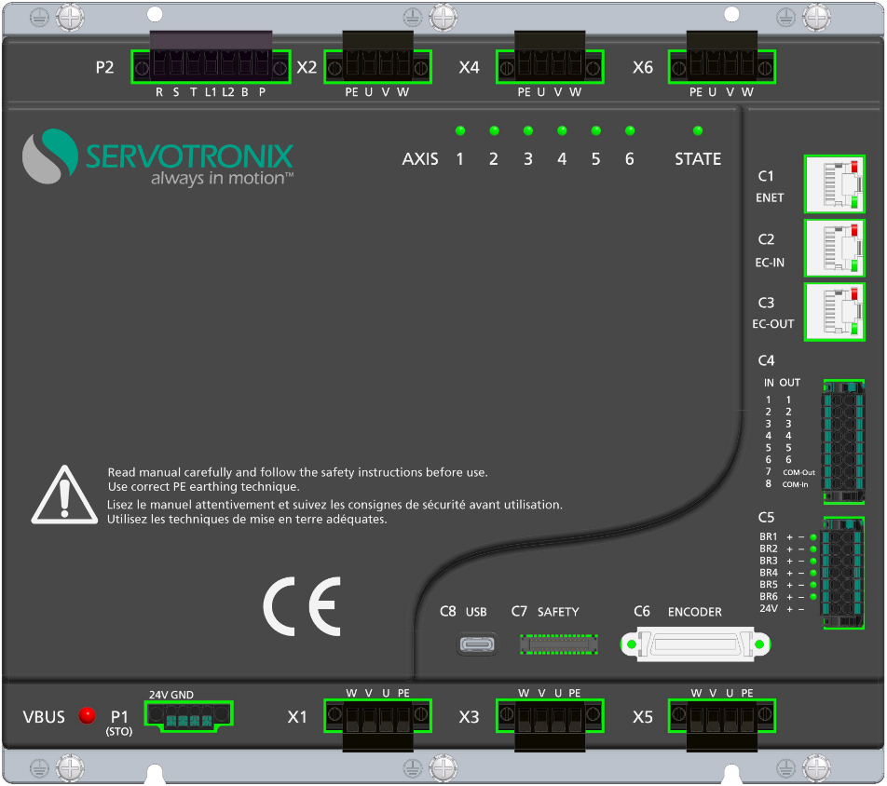

Revision History
Doc. Rev. | Date | Remarks
1.2 | 12 Feb. 2024 | Minor corrections in Warnings and Faults chapter
1.1 | 31 Jan. 2024 | Added Warnings, Faults, Inhibits.
1.0 | 1 Nov. 2023 | Preliminary release.
Copyright
© 2024 Servotronix Motion Control Ltd.
All rights reserved. No part of this work may be reproduced or transmitted in any form or by any means without prior written permission of Servotronix Motion Control Ltd.
Disclaimer
This product documentation was accurate and reliable at the time of its release. Servotronix Motion Control Ltd. reserves the right to change the specifications of the product described in this manual without notice at any time.
Trademarks
smartPX, ServoStudio+ and sensAR are trademarks of Servotronix Motion Control Ltd.
CANopen and CiA are registered trademarks of the CAN in Automation User's Group.
EtherCAT is a registered trademark of Beckhoff Automation GmbH.
Windows is a registered trademark of Microsoft Corporation.
Contact Information
Servotronix Motion Control Ltd.
21C Yagia Kapayim Street
Petach Tikva 49130 Israel
Tel: +972 (3) 927 3800
Fax: +972 (3) 922 8075
Website: www.servotronix.com
Technical Support
If you need assistance with the installation and configuration of the product, contact Servotronix technical support: tech.support@servotronix.com
Contents
1 Introduction
1.1 smartPX Product Description 5
1.2 Ordering Information 6
1.3 Product Package 7
2 Safety and Standards
2.1 Safety Symbols 8
2.2 Safety Guidelines 8
2.2.1 Installation Safety 9
2.2.2 Operational Safety 9
2.2.3 Maintenance Safety 10
3 Specifications
3.1 Dimensions 11
3.2 Electrical and Mechanical Specifications 12
3.3 Control Specifications 13
3.4 Environmental Specifications 14
3.5 STO/Functional Safety Specifications 14
3.6 Communication Specifications 14
3.7 I/O Specifications 15
3.8 Motor Feedback Specifications 16
4 Installation
4.1 Installation Overview 17
4.2 System Wiring Guidelines 18
4.2.1 Grounding 19
4.2.2 Shielding and Bonding 20
4.2.3 Input Power Filtering 20
4.3 Regeneration 20
4.4 Mounting 21
5 Interfaces
5.1 Control Board 23
5.1.1 Interface C4 – Digital Inputs and Digital Outputs 23
5.1.2 Interface C5 – Motor Brake 24
5.1.3 Interface C6 – Encoder (Motor Feedback) 25
5.1.4 Interface C7 – Safety I/Os – not yet implemented 26
5.1.5 Interfaces C1, C2, C3 – Fieldbus Communication 27
5.2 Power Board 28
5.2.1 Interface P1 – STO 28
5.2.2 Interface P2 – Power 29
5.2.3 Interfaces X1 – X6 – Motor Power 30
5.2.4 Interface C8 – USB 31
5.3 Status LEDs 31
5.4 Power Up 32
6 Interface Circuitry
6.1 Digital Inputs Circuitry 33
6.2 Digital Output Circuitry 34
6.3 Motor Brake Circuitry 35
7 ServoStudio+
7.1 Software Installation 36
7.2 Activation 36
7.3 Parameter Values 38
8 Drive Configuration
8.1 Motors 39
8.1.1 Load Motor Parameters 39
8.1.2 Modify Motor Parameters 40
8.1.3 Copy Parameter Values to Another Motor 41
8.1.4 Save Motor Parameters 41
8.2 Feedback 42
8.3 Limits 44
8.4 Digital I/Os 45
8.5 Autotune 46
8.6 Control Loop 48
8.7 Upgrade Drive Firmware 51
9 Warnings and Faults
9.1 Warning Codes 52
9.2 Fault Codes 55
9.3 Inhibit Codes 64

Introduction

smartPX Product Description
The smartPX is a six-axis servo drive developed by Servotronix that supports rotary motors with brakes. The drive is primarily, but not exclusively, intended for use in robot applications.
Figure ‎1-1. smartPX 6-Axis Servo Drive

Ordering Information
 |  | PX | – | 6 | – | A | – | 2A | – | EC | – | RO | – | ST | – | M | – | NN
 | smartPX multi-axis servo drive series
 | Number of Axes
6 | Supports 6 axes
4 | Supports 4 axes *
 | Power
A
  Axis | Rated  Arms | Max  Arms
  1 | 4.5 | 18.1
  2 | 4.5 | 18.1
  3 | 3 | 13.6
  4 | 2 | 9.1
  5 | 2 | 9.1
  6 | 2 | 9.1
 | Voltage
2A | 1-phase 220 VAC, -15%/+20%, 50/60 Hz
4D | 3-phase 220 VAC, -15%/+20%, 50/60 Hz
 | Communication
EC | EtherCAT
PN | Profinet *
CN | CANopen *
 | Motor Type
R | Supports rotary motor only
L | Supports linear motor/rotary motor *
 | Safety
ST | STO function only
SA | Safety functions – STO/SS1/SBC *
 | Feedback Type
M | Supports sensAR/Tamagawa encoders
 | Controller Type
MC | softMC *
CS | CodeSys *
NN | Not installed
* In development. Feature will be supported in the future.

Product Package
The smartPX package includes:
- smartPX multi-axis servo drive
- STO bypass plug
- Mating connectors, as specified in the following table. For more details, refer to Chapter 5: Interfaces.
Table ‎1-1. Mating Connectors
Part Description | Servotronix Part Number | Quantity
P1 STO connector | 15EDGKNM-4P4-GSn-3.5 | 1
P2 AC IN connector | 2EDGKMB-7P7-BKSn-5.08 | 1
X1-X6 Motor connector | 2EDGKMB-4P4-BKSn-5.08 | 6
C4 I/O connector | 15EDGKNHGB-16P16-BKSn-3.5 | 1
C5 Brakes connector | 15EDGKNHGB-14P14-BKSn-3.5 | 1

Safety and Standards

Safety Symbols
Safety symbols indicate a potential for personal injury or equipment damage if the prescribed precautions and safe operating practices are not followed.
The following safety-alert symbols are used on drive and in the documentation.
Symbol | Meaning | Description | ISO 7000/  IEC 60417
 | Caution | Indicates caution is necessary when operating the device.  Also indicates the current situation needs operator awareness or operator action to avoid undesirable consequences. | 0434
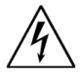 | Dangerous voltage | Indicates hazards arising from dangerous voltages. | 5036
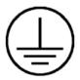 | Protective earth;  protective ground | Identifies any terminal which is intended for connection to an external conductor for protection against electric shock in case of a fault, or the terminal of a protective earth (ground) electrode. | 5019

Safety Guidelines
The smartPX servo drive is intended for use as a component within a machine system.
The machine builder and integrator must ensure the protection of both personnel and the complete machine system.
The machine builder and/or integrator must perform a risk assessment in view of using the smartPX drive in the intended application. Based on the results, the appropriate safety measures must be implemented.
The smartPX drive must be used in compliance with all applicable safety regulations and directives, and all technical specifications and requirements.
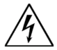 | The smartPX drive utilizes hazardous voltages. It must be properly grounded.

The machine builder and the machine owner are responsible for the safety of the machine operators.

The machine owner and the machine operator are responsible for ensuring personnel cannot enter the hazard zone while the machine is energized unless adequate functional safety mechanisms are in place.

Only qualified personnel may perform installation, operation, service and maintenance procedures. These persons must have sufficient technical training and knowledge to foresee and recognize potential hazards that may occur when using the product, modifying settings, and operating the mechanical, electrical and electronic components of the entire machine system.
All persons working on and with the product must be fully familiar with all applicable standards, directives, and accident prevention regulations when performing such work.

Installation Safety
Note | Incorrect handling of the smartPX may cause personal injury and/or damage to equipment.

When connecting the smartPX to other control equipment, be sure to follow two basic guidelines to prevent damage to the drive:
- The smartPX must be grounded via the earth ground of the main AC voltage supply.
- Any motion controller, PLC or PC that is connected to the smartPX must be grounded to the same earth ground as the smartPX.

- Before installing or commissioning the smartPX, review all relevant product documentation.
- Perform the installation in strict compliance with product specifications and installation instructions.
- All system components must be connected to ground. Electrical safety is provided through a low-resistance earth ground connection. (Protective Class 1 according standard EN/IEC 618005-1.) The motor should be connected to protective earth by an independent earthing conductor rated not less than the motor wire.
- As part of the machine design, the machine builder must generate a hazard analysis for the machine and take appropriate measures to ensure that unforeseen movements cannot cause personal injury and/or damage to equipment.
- Wiring of a yellow color with or without one or more green stripes must not be used, except for protective bonding.
- Power cables should be rated at least 600V, 75℃.

Operational Safety
Note | Machine builders are responsible for machine safety implementation, testing and certification. The machine manual must define operational and maintenance conditions and safety precautions.

- Perform all machine operations in strict compliance with product specifications and installation instructions.
- The machine builder must provide a power disconnect device in accordance with local regulations.
- During operation, keep all covers and cabinet doors shut.
- During operation the machine has electrically charged components and hot surfaces. Power cables can carry a high voltage, even when the motor is not rotating.
- Machine axes with a suspended load or unbalanced load must have an additional mechanical safety block(such as a motor-holding brake) to prevent the load from falling out of control. The smartPX cannot keep the load suspended when STO is active. Serious injury may result if the load is not properly safeguarded.

Maintenance Safety
Note | Incorrect handling of the smartPX may cause personal injury and/or damage to equipment.

- Before performing maintenance on the smartPX (or the machine it drives), review all relevant product documentation.
- Perform maintenance procedures in strict compliance with the product maintenance requirements and instructions.
- To prevent electric arcing and hazards to personnel and electric contacts, never disconnect of connect the product while the power source is energized.
- After disconnecting the power source from the machine, wait at least 5 minutes before touching or disconnecting parts of the machine that normally carry electrical charges (such as capacitors, contacts, screwed connections).
- Before touching the machine, measure the electrical contact points with a meter. Be certain voltage is below 30 VDC before handling components.

Specifications

Dimensions
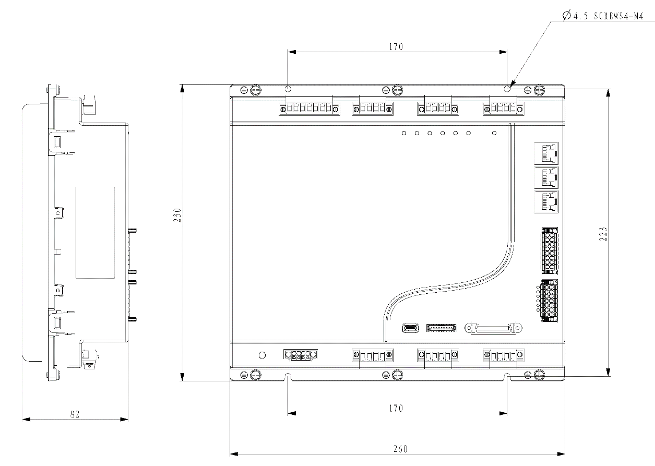
Figure ‎3-1. Dimensions (mm)

Electrical and Mechanical Specifications
Table ‎3-1. Electrical and Mechanical Specifications
Feature | Specification
Input power | Input AC line voltage | 1-phase/3-phase:  220 VAC, -15%/+20%
Input power | Line Frequency | 47–63 Hz
Input power | Continuous (rated) current | 16.5 A
STO | Voltage | 24V, -15%/+20%
STO | Peak (max) input current for 2 seconds | 0.38A
Logic supply | Voltage | 220 VAC, -15%/+20%
Logic supply | Peak (max) input current for 2 seconds | 0.18A
Drive output | Axis 1 – Continuous (rated) current | 4.5 Arms
Drive output | Axis 1 – Peak (max) current for 2 seconds | 18.1 Arms
Drive output | Axis 2 – Continuous (rated) current | 4.5 Arms
Drive output | Axis 2 – Peak (max) current for 2 seconds | 18.1 Arms
Drive output | Axis 3 – Continuous (rated) current | 3 Arms
Drive output | Axis 3 – Peak (max) current for 2 seconds | 13.6 Arms
Drive output | Axis 4 – Continuous (rated) current | 2 Arms
Drive output | Axis 4 – Peak (max) current for 2 seconds | 9.1 Arms
Drive output | Axis 5 – Continuous (rated) current | 2 Arms
Drive output | Axis 5 – Peak (max) current for 2 seconds | 9.1 Arms
Drive output | Axis 6 – Continuous (rated) current | 2 Arms
Drive output | Axis 6 – Peak (max) current for 2 seconds | 9.1 Arms
Drive output | PWM frequency | 16 kHz
External regen resistor | Operation DC bus voltage | 400 VDC
External regen resistor | Minimum resistance | 30 Ω

Control Specifications
Table ‎3-2. Control Specifications
Feature | Specification
Motors | Types | Rotary servo
Motors | Motor Phasing | Automatic configuration of motor phasing, phase-swapping
Motors | Motor Direction | Clockwise/counter-clockwise, encoder direction
Operation Modes | Control Modes | Current control, Velocity control, Position control, Continuous synchronous position, Continuous synchronous torque
Current (Torque) Control | Update Rate | 62.5 μs (16 kHz)
Current (Torque) Control | Control Loop | PI, Feedforward
Current (Torque) Control | Autotuning | Automatic setting of current control loop parameters
Velocity Control | Update Rate | 125 μs (8 kHz)
Velocity Control | Control Loop | PDFF, Feedforward
Velocity Control | Filters | First order low pass filter, Double first order low pass filter, Notch filters, High pass filter, Band pass filter, User defined polynomial filter
Position Control | Update Rate | 125 μs (8 kHz),
Position Control | Control Loop | PID controller,
Reference Command | Protocol | CANopen over EtherCAT (CoE)
Advanced Control Functions |  | Velocity observer, Friction compensation, Harmonic compensation, Collision detection, Input shaping, Gain scheduling
Tuning | Methods | Autotuning, Frequency analyzer, Inertia and friction estimation
Rotary Units | Position | Revolutions, counts, degrees
Rotary Units | Velocity | rps, rpm, deg/s
Rotary Units | Acc/Dec | rps/s, rpm/s, deg/s²
User Interface | GUI | ServoStudio+
User Interface | Functions | Configuration, Tuning, Monitoring, Analysis

Environmental Specifications
Table ‎3-3. Environmental Specifications
Feature | Specification
Protection class | IP20, pollution degree: 2 as per IEC 60664-1 Do not use in the following locations: corrosive or flammable gasses, water oil or chemical, dust including iron dust and salts
Ambient temperature | 0° to 45°C no derating
Storage temperature | 0° to 70°C
Humidity | 10 to 90%
Altitude | <1000m no derating
Vibration | 1.0g

STO/Functional Safety Specifications
Note | STO certification pending.

Table ‎3-4. STO/Functional Safety Specifications
Feature | Specification
Nominal voltage | 24 VDC
Voltage levels | 15–30 VDC STO function not active (motion allowed)  0–5 VDC STO function active (motion not allowed)  5–15 VDC STO function not defined and not guaranteed
Power supply – external | SELV/PELV required
Power supply – internal | STO jumper required
Maximum reaction time | 30 ms

Communication Specifications
Table ‎3-5. Communication Specifications
Feature | Specification
Fieldbus | Type | EtherCAT over Ethernet (CoE), 100 Mbit
Fieldbus | Communication cycle time (minimum) | 500 µs
Fieldbus | Device configuration file | IEC61800-7 Profile type1 (CiA402)  CoE (CANopen over EtherCAT)
Fieldbus | Communication object | PDO (Process Data Object)  SDO (Service Data Object)
Fieldbus | Synchronization type | SYNC0 Event Synchronization

I/O Specifications
Table ‎3-6. STO/Functional Safety Specifications
Feature | Specification
Digital inputs | Quantity | 4
Digital inputs | Signal | Opto-isolated.  All 4 digital inputs must be wired/used either as sink or as source.
Digital inputs | Voltage | 24V – External, user-supplied  On: 11 to 30 VDC  Off: 0 to 5 VDC
Digital inputs | Max. input current | 12.5 mA per input
Digital inputs | Propagation delay time | 1 ms
Fast digital inputs | Quantity | 4
Fast digital inputs | Signal | Opto-isolated.  All 4 digital inputs must be wired/used either as sink or as source.
Fast digital inputs | Voltage | 24V – External, user-supplied  On: 11 to 30 VDC  Off: 0 to 5 VDC
Fast digital inputs | Max. input current | 12.5 mA per input
Fast digital inputs | Propagation delay time | 1 μs
Digital outputs | Quantity | 6
Digital outputs | Signal | Opto-isolated.  All 6 digital outputs must be wired/used either as sink or as source.
Digital outputs | Voltage | 24 V
Digital outputs | Max. output current | 50 mA
Digital outputs | Propagation delay time | 1 ms
Motor brakes | Quantity | 6, independently controlled outputs
Motor brakes | Voltage | 24V
Motor brakes | Maximum current per axis | 1A
Motor brakes | Maximum current total | 6A

Motor Feedback Specifications
Table ‎3-7. Motor Feedback Specifications
Feature | Specification
Supply voltage from drive | 5.15 VDC ±2%
Max. supply current from drive | 720 mA per axis
Recommended cable type | Shielded twisted-pair copper wire
Encoder type | Tamagawa MT absolute encoder, multi-turn 16-bit/single-turn 17-bit/23-bit, 2.5 Mbps
Encoder type | Tamagawa ST absolute encoder,  single-turn 17-bit/23-bit, 2.5 Mbps
Encoder type | Servotronix sensAR absolute encoder,  multi-turn 16-bit/single-turn 20-bit, 2.5 Mbps

Installation

Installation Overview
Perform the following steps to install and setup a smartPX system.
- Mount the smartPX.
- Make all wiring and cable connections, as required by your application:
- I/Os
- Motor feedback devices (encoders)
- Fieldbus devices, if in use
- Safe torque off (STO), or bypass using jumpers
- Motors
- Regeneration resistor, if required
- Motor brakes, if required
- AC and DC input voltage
- Fans
- Safety relay, if required
- Connect the drive to the user computer.
- Power up the drive and the user computer.
- Install ServoStudio+ software.

System Wiring Guidelines
When connecting the smartPX to other control equipment, be sure to follow two basic guidelines to prevent damage to the drive:
- The smartPX must be grounded via the earth ground of the main AC voltage supply.
- Any motion controller, PLC or PC that is connected to the smartPX must be grounded to the same earth ground as the smartPX.
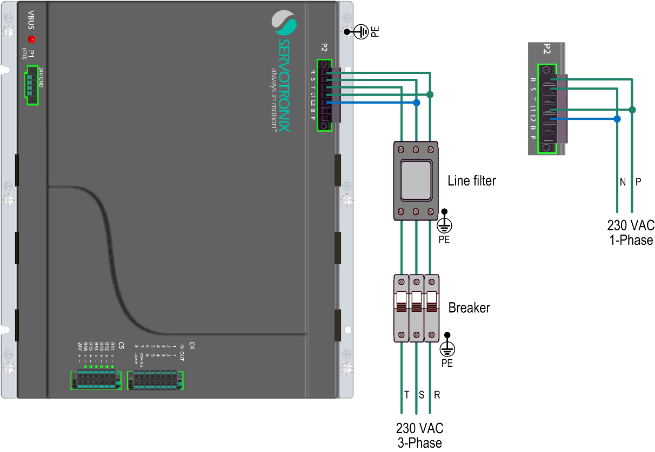
Figure ‎4-1. High voltage wiring
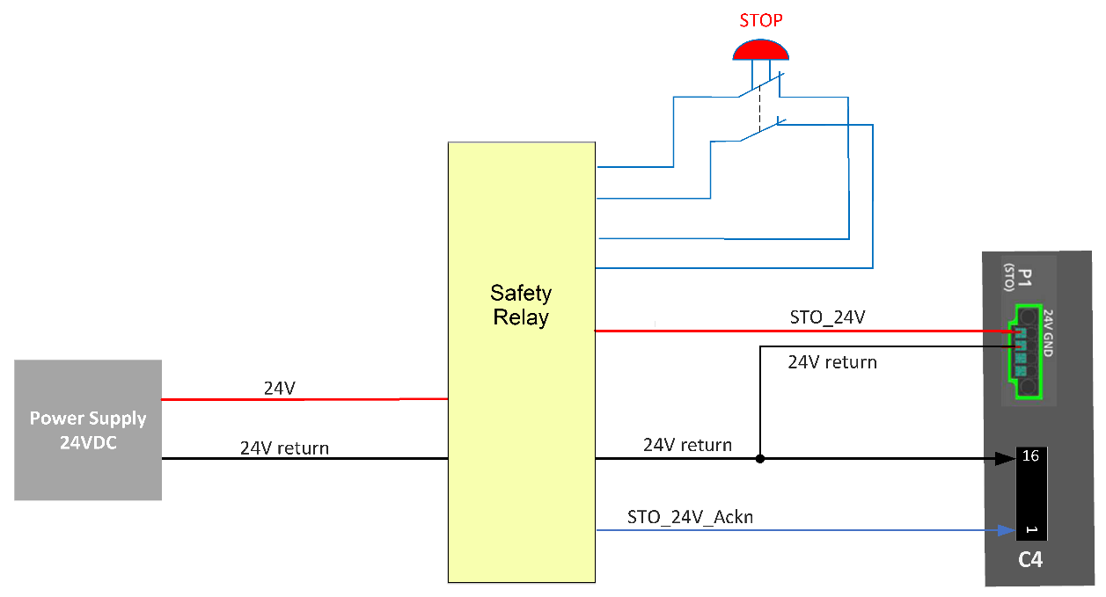
Figure ‎4-2. Emergency stop wiring

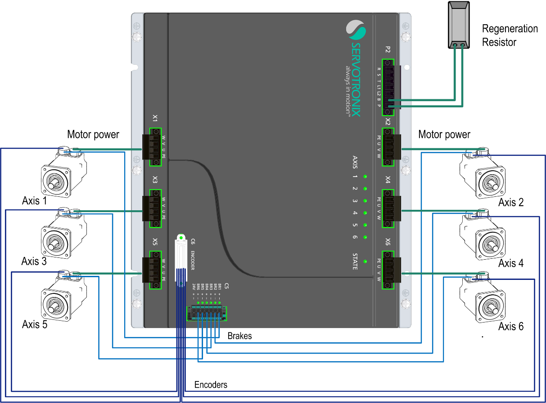
Figure ‎4-3. Motors wiring

Grounding
System grounding is essential for proper performance of the drive system.
The AC input voltage ground wire must be connected to a PE terminal on the drive. This is necessary for both safety and EMI reduction.
Use a single point ground for the system (star wiring) to avoid ground loops.
It is strongly recommended that the smartPX be mounted to a metallic back panel, and that a high frequency ground be provided to connect the back panel to earth ground. Provide an electrical connection across the entire back surface of the drive panel. Electrically-conductive panels such as aluminum or galvanized steel are recommended. For painted and other coated metal panels, remove all coating behind the drive. The objective is to provide an extremely low impedance path between the filters, drives, power supplies, and earth ground for high-frequency signals that might cause EMI. Use a flat braid or copper busbar to achieve high-frequency grounding. Use the shortest braid possible when connecting high frequency grounds.
Ensure good connections between the cabinet components. Connect the back panel and cabinet door to the cabinet body using several conductive braids. Never rely on hinges or mounting bolts for ground connections. Ensure good ground connection from cabinet to proper earth ground. Ground leads should be the same gauge as the leads to main power or one gauge smaller.
The user computer must also be properly grounded.

Shielding and Bonding
To minimize noise emissions and maximize the immunity levels of the drive system, motor and feedback cables must be shielded and properly bonded to a grounded surface.
The shield must be connected to ground at both ends of the cable. Its effect is to reduce the impedance between the cable shield and the back panel.
It is recommended that all shielded cables be bonded to the back panel.
The motor and feedback shielded cables should be exposed as close as possible to the drive. This exposed cable shield is bonded to the back panel using either non-insulated metallic cable clamps or cable bonding clamps.
It is recommended to use a star point shield connection with a shielding busbar.

Input Power Filtering
The drive’s electronic system components require EMI AC line filtering in the input power leads to meet the CE requirements for the industrial environment.
Care must be taken to adequately size the system. The type of filter is determined according to the voltage and current rating of the system and whether the incoming line is single phase or three phase. One input line filter can be used for multi-axis control applications.
Implementation of the input power filter must adhere to the following guidelines:
- Maintain separation of leads entering and exiting the mains filter.
- Filter must be mounted on the same panel as the drive.
- Filter must be mounted as close as possible to the drive, to prevent noise from being capacitively coupled into other signal leads and cables.
- When mounting the filter to the panel, remove any paint or material covering. Use an unpainted metallic back panel, if possible.
- Filters are provided with a ground terminal, which must be connected to ground.
- Filters can produce high leakage currents. Filters must be grounded before connecting the supply.
- Filters should not be touched for 10 seconds after removing the supply.

Regeneration
When a motor and load decelerate rapidly, kinetic energy of the load drives the motor shaft energy back to the drive. This regeneration energy must be dissipated or absorbed.
Regenerative energy that is not dissipated is added to the electrical energy already stored in the capacitors of bus module. If the capacitors can absorb the energy, the system does not require a regeneration resistor. However, if excessive energy is added, the voltage on the capacitors will exceed the over-voltage threshold, which then disables the drive.
To prevent over-voltage, and potential damage to the system, excessive regenerative energy must be dissipated by a regeneration resistor.
If your application requires a regenerative resistor for braking a high inertia load during emergency stops, connect an external regenerative resistor to interface P2, terminals B and P.

Mounting
The smartPX can be mounted in either a horizontal or vertical position.
In addition, the drive can be mounted entirely within a cabinet, or with the heatsink protruding through the back of the cabinet.
It is important to maintain an ambient temperature that does not exceed 45°C. Therefore, two cooling fans must also be installed near the smartPX on the side of the main Power interface (P2). The recommended distance is 30 mm.
The distance between the two fans, the smartPX, the cabinet and/or other objects must also be at least 30 mm.
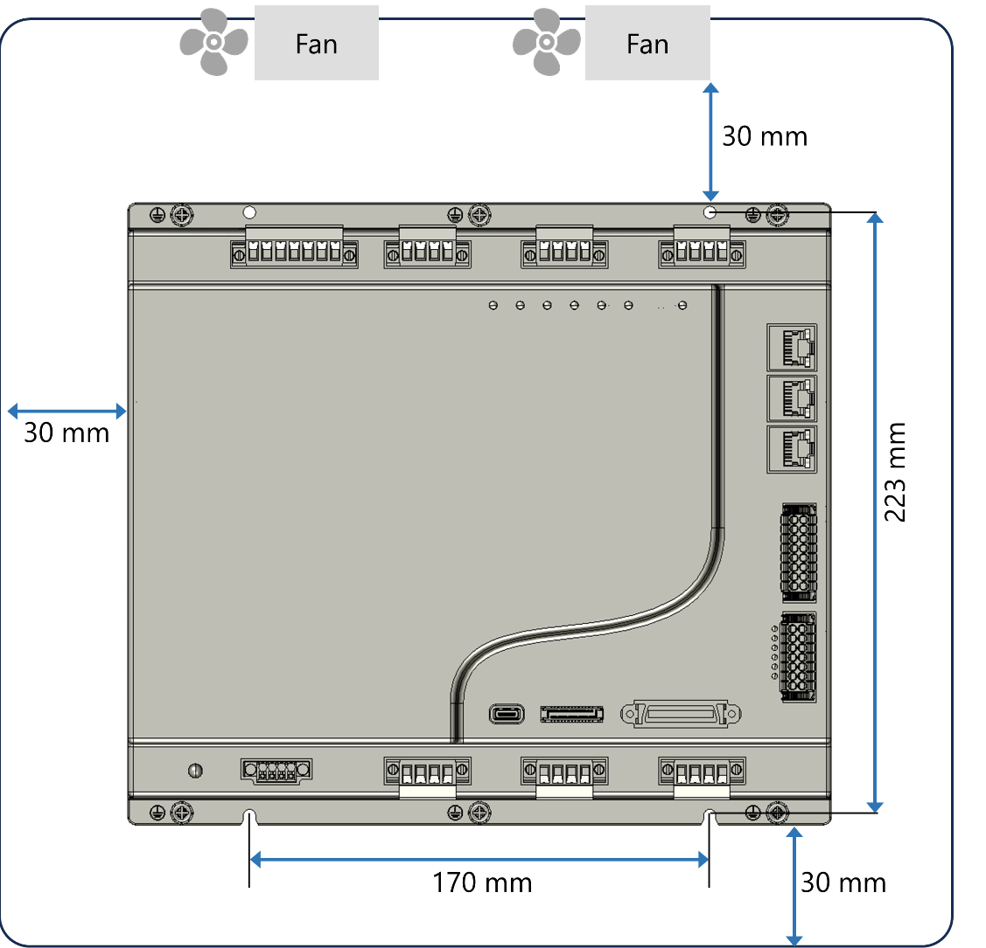
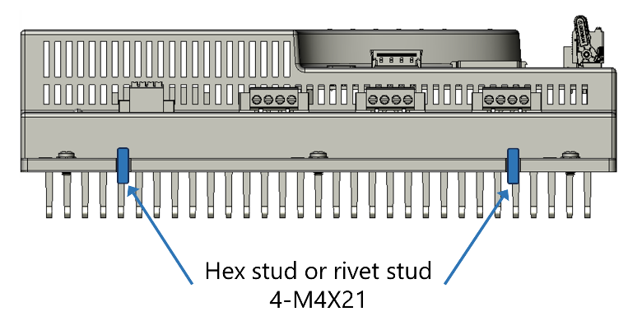
Figure ‎4-4. Mounting dimensions

Interfaces
All electrical interfaces are on the top panel of the smartPX.
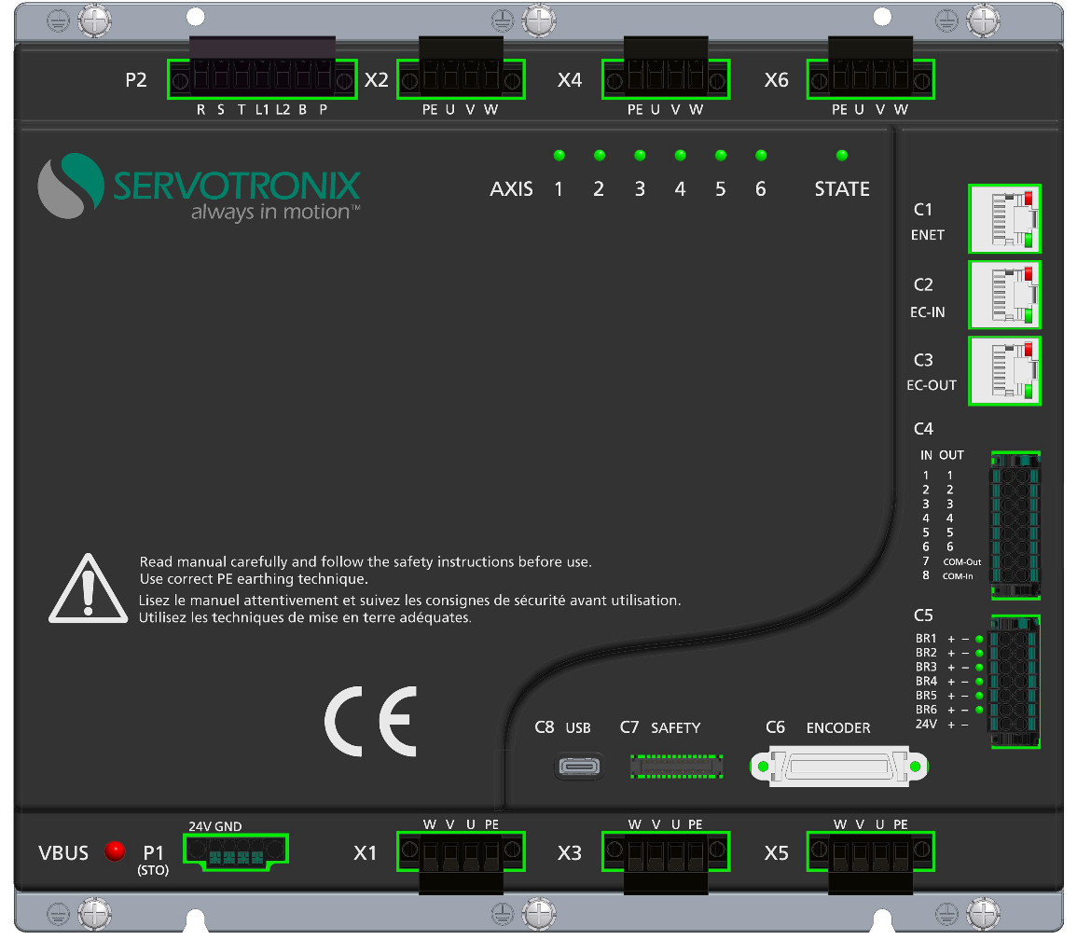
Figure ‎5-1. SmartPX Electrical Interfaces

Control Board

Interface C4 – Digital Inputs and Digital Outputs
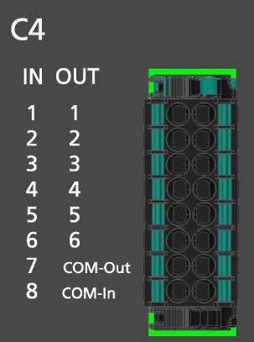
Figure ‎5-2. Interface C4
All digital inputs and digital outputs on all smartPX models are opto-isolated.
Wire the digital inputs and outputs according to the requirements of your application. Unused pins must remain unwired.
Note | All 8 digital inputs must be wired/used either as sink or as source.  All 6 digital outputs must wired/used either as sink or as source.
Table ‎5-1. Interface C4 Pinout
Pin | Label | Description | Pin | Label | Description
1 | IN 1 | Opto-isolated digital input 1. | 2 | OUT 1 | Opto-isolated digital output 1.
3 | IN 2 | Opto-isolated digital input 2. | 4 | OUT 2 | Opto-isolated digital output 2.
5 | IN 3 | Opto-isolated digital input 3. | 6 | OUT 3 | Opto-isolated digital output 3.
7 | IN 4 | Opto-isolated digital input 4. | 8 | OUT 4 | Opto-isolated digital output 4.
9 | IN 5 | Opto-isolated digital input 5. Supports 500 kHz fast input. | 10 | OUT 5 | Opto-isolated digital output 5.
11 | IN 6 | Opto-isolated digital input 6. Supports 500 kHz fast input. | 12 | OUT 6 | Opto-isolated digital output 6.
13 | IN 7 | Opto-isolated digital input 7. Supports 500 kHz fast input. | 14 | COM OUT | Common output
15 | IN 8 | Opto-isolated digital input 8. Supports 500 kHz fast input. | 16 | COM IN | Common input
Table ‎5-2. Interface C4 Mating Connector
Connector | Pluggable terminal block, pitch 3.5 mm, 2*8
Mating connector | DEGSON 15EDGKNHG-3.5-16P-13-28Z(H)

Interface C5 – Motor Brake
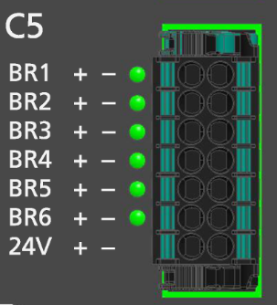
Figure ‎5-3. Interface C5
Table ‎5-3. Interface C5 Pinout
Pin | Label | Description | Pin | Label | Description
1 | BR 1 + | Motor 1 brake output + | 2 | BR 1 – | Motor 1 brake output -
3 | BR 2 + | Motor 2 brake output + | 4 | BR 2 – | Motor 2 brake output -
5 | BR 3 + | Motor 3 brake output + | 6 | BR 3 – | Motor 3 brake output -
7 | BR 4 + | Motor 4 brake output + | 8 | BR 4 – | Motor 4 brake output -
9 | BR 5 + | Motor 5 brake output + | 10 | BR 5 – | Motor 5 brake output -
11 | BR 6 + | Motor 6 brake output + | 12 | BR 6 – | Motor 6 brake output -
13 | 24 V + | Motor brake power 24 VDC | 14 | 24 V – | Motor brake power 24 VDC return
Table ‎5-4. Interface C5 Mating Connector
Connector | Pluggable terminal block, pitch 3.5 mm, 2*8
Mating connector | DEGSON 15EDGKNHG-3.5-14P-13-28Z(H)

Interface C6 – Encoder (Motor Feedback)
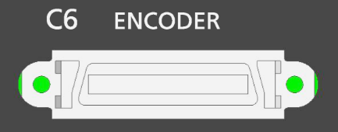
Figure ‎5-4. Interface C6
Wire the digital inputs and outputs according to the requirements of your application. Unused pins must remain unwired.
Table ‎5-5. Interface C6 Pinout
Pin | Function | Description
1 |  | Reserved. Not in use.
2 |  | Reserved. Not in use.
3 |  | Reserved. Not in use.
4 |  | Reserved. Not in use.
5 |  | Reserved. Not in use.
6 |  | Reserved. Not in use.
7 | GND_6 | Axis 6 Ground (5V return)
8 | ENC_Dn_Ax6 | Axis 6 Serial encoder data -
9 | GND | Axis 5 Ground (5V return)
10 | ENC_Dn_Ax5 | Axis 5 Serial encoder data -
11 | GND | Axis 4 Ground (5V return)
12 | ENC_Dn_Ax4 | Axis 4 Serial encoder data -
13 | GND | Axis 3 Ground (5V return)
14 | ENC_Dn_Ax3 | Axis 3 Serial encoder data -
15 | GND | Axis 2 Ground (5V return)
16 | ENC_Dn_Ax2 | Axis 2 Serial encoder data -
17 | GND | Axis 1 Ground (5V return)
18 | ENC_Dn_Ax1 | Axis 1 Serial encoder data -
19 |  | Reserved. Not in use.
20 |  | Reserved. Not in use.
21 |  | Reserved. Not in use.
22 |  | Reserved. Not in use.
23 |  | Reserved. Not in use.
24 |  | Reserved. Not in use.
25 | Enc_5V_Ax6 | Axis 6 Power supply 5V
26 | ENC_Dp_Ax6 | Axis 6 Serial encoder data +
27 | Enc_5V_Ax5 | Axis 5 Power supply 5V
28 | ENC_Dp_Ax5 | Axis 5 Serial encoder data +
29 | Enc_5V_Ax4 | Axis 4 Power supply 5V
30 | ENC_Dp_Ax4 | Axis 4 Serial encoder data +
31 | Enc_5V_Ax3 | Axis 3 Power supply 5V
32 | ENC_Dp_Ax3 | Axis 3 Serial encoder data +
33 | Enc_5V_Ax2 | Axis 2 Power supply 5V
34 | ENC_Dp_Ax2 | Axis 2 Serial encoder data +
35 | Enc_5V_Ax1 | Axis 1 Power supply 5V
36 | ENC_Dp_Ax1 | Axis 1 Serial encoder data +
Table ‎5-6. Interface C6 Mating Connector
Mating connector (shell) | 3M 10336-52F0-008  D-subminiature connector 36P junction shell SLD
Mating connector (plug) | 3M 10136-3000PE  D-subminiature connector 36P MDR plug

Interface C7 – Safety I/Os – not yet implemented
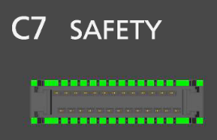
Figure ‎5-5. Interface C7

Interfaces C1, C2, C3 – Fieldbus Communication
Interfaces C1, C2 and C3 are RJ45 ports that serve as transmitter and receiver for a drive operating on a EtherCAT network.
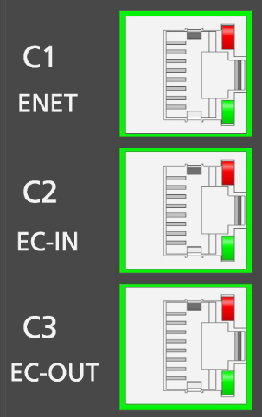
Figure ‎5-6. Interfaces C1 C2 C3
Table ‎5-7. Interfaces C1 C2 C3 Pinout
Pin | Name | Description
1 | TX+_D1 | Transmit data +
2 | TX-_D1 | Transmit data -
3 | RX+_D2 | Receive data +
4
5
6 | RX-_D2 | Receive data -
7
8
Table ‎5-8. Interfaces C1 C2 C3 Mating Connector
Mating connector | Any RJ45 CAT6 compatible shielded connector
Cable | CAT6 or higher, standard Ethernet straight cable

Power Board
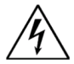 | Make sure the main voltage rating matches the drive specification. Applying incorrect voltage may cause drive failure.  Do not apply power until all hardware connections are complete.

Interface P1 – STO
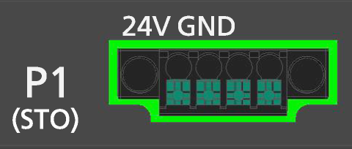
Figure ‎5-7. Interface P1
Table ‎5-9. Interface P1 Pinout
Pin | Label | Function
1 | 24V | STO Power Supply (STO Enable)
2 | GND | STO Return
3 | GND | Reserved for STO. Internal return.
4 | 24V | Reserved for STO. Internal supply.

Table ‎5-10. Interface P1 Mating Connector
Connector (socket) | DEGSON 15EDGVM-THR-3.5-04P-13-10Z(H)
Mating connector (plug) | DEGSON 15EDGKNM-3.5-04P-14-1022Z(H)
Wire gauge | 24–20 AWG
Strip length | 20 mm

STO Enable and STO Return must be connected to enable smartPX operation.
The STO Enable signal voltage must be 24 VDC.
Note | If the application does not require STO control, jumper pin 4 to pin 1, and pin 3 to pin 2, to bypass the STO, using the STO bypass plug supplied with the smartPX.
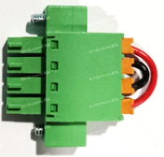
Figure ‎5-8. STO Bypass Plug

Interface P2 – Power
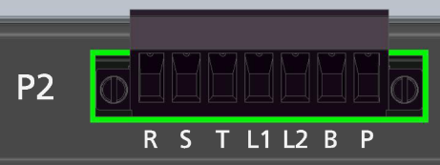
Figure ‎5-9. Interface P2
Table ‎5-11. Interface P2 Pinout
Pin | Label | Description
1 | R | AC Phase 1 (L1) (Reference)
2 | S | VAC AC Phase 2 (L2) (Secondary)
3 | T | VAC AC Phase 3 (L3) (Tertiary)
4 | L1 | Logic AC (phase)
5 | L2 | Logic AC (neutral)
6 | B | Regen + (DC bus +)
7 | P | Regen -
Table ‎5-12. Interface P2 Mating Connector
Connector (socket) | DEGSON 2EDGVM-5.08-07P-13-100Z(H)
Mating connector (plug) | DEGSON 2EDGKM-5.08-07P-13-1000A(H)
Wire gauge | 28–12 AWG
Strip length | 7 mm

Make sure the main voltage rating matches the drive specification. Applying incorrect voltage may cause drive failure.
Do not apply power until all hardware connections are complete.

Prevent inrush surge:
Bus Power (R-S-T): After switching off bus power, wait 1 minute before switching on again.
Logic Power (L1-L2): After switching off logic power, wait 1 minute before switching on again.

Procedure: Connecting Power
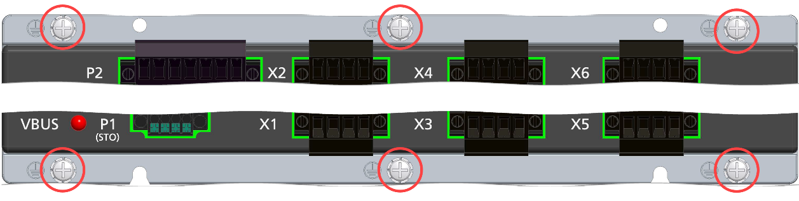
Figure ‎5-10. Ground Terminals
The smartPX has 4 ground PE terminals, located on its mounting plate/heatsink.
- Connect the AC input voltage ground wire to one of the PE terminals. Use an M4 ring or spade terminal.
- Connect R, S and T (for bus power).
- If the main voltage is from a single-phase source, connect line and neutral to R and T.
- If the main voltage is from a three-phase source, connect the phases to R, S and T.
- Connect L1 and L2 (for logic power).
- If the main voltage is from a single-phase source, connect line and neutral to L1 and L2.
- If the main voltage is from a 3-phase source, connect any two phases to L1 and L2.

Interfaces X1 – X6 – Motor Power
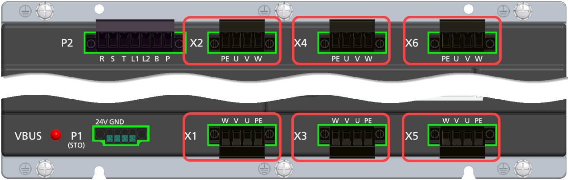
Figure ‎5-11. Interfaces X1 – X6
Table ‎5-13. Interfaces X1 – X6 Pinout
Pin | Label | Description
1 | PE | Protective ground
2 | U | Motor phase U
3 | V | Motor phase V
4 | W | Motor phase W
Table ‎5-14. Interfaces X1 – X6 Mating Connector
Connector (socket) | DEGSON 2EDGVM-5.08-04P-13-100Z(H)
Mating connector (plug) | DEGSON 2EDGKM-5.08-04P-13-1000A(H)
Wire gauge | 28–12 AWG
Strip length | 7 mm

Interface C8 – USB
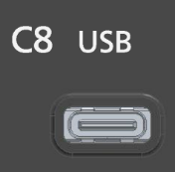
Figure ‎5-12. Interface C8
C8 is a USB type C port that enables save and restore of program and data files from/to the smartPX.
To backup and restore files, you must use the ServoStudio+ software.

Status LEDs

Figure ‎5-13. Status LEDs

State LED
Table ‎5-15. State LED
Color/Behavior | Meaning
Red | Fault (including “inhibit”)
Green | All axes are enabled
Blinking green | Some of the axes are enabled
Blue | Drive is operational, but no axis is enabled
Blinking blue | E-stop inputs are activated

Axis LEDs
Table ‎5-16. Axis Status LED
Color/Behavior | Meaning
Green | Axis is enabled
Red | Axis is disabled
Blinking red | Axis has fault

Vbus LED

Figure ‎5-14. Voltage LED
The Vbus LED provides a high voltage warning.
Do not touch or attempt to disconnect any cables until the LED shuts off.
Table ‎5-17. Vbus LED
Color/Behavior | Meaning
Red On | Vbus higher than 60V
Red Off | Vbus less than 60V

Brake LEDs
Figure ‎5-15. Brake LEDs
Table ‎5-18. Brake LEDs
Color/Behavior | Meaning
Green On | Brake released.
Green Off | Brake engaged.

Power Up
After completing all hardware connections, you can turn on power to the drive.
Check the status LEDs after the drive is powered on.

Interface Circuitry

Digital Inputs Circuitry
Note | Input ON range: 11–30 VDC  Input OFF range: 0–5 VDC

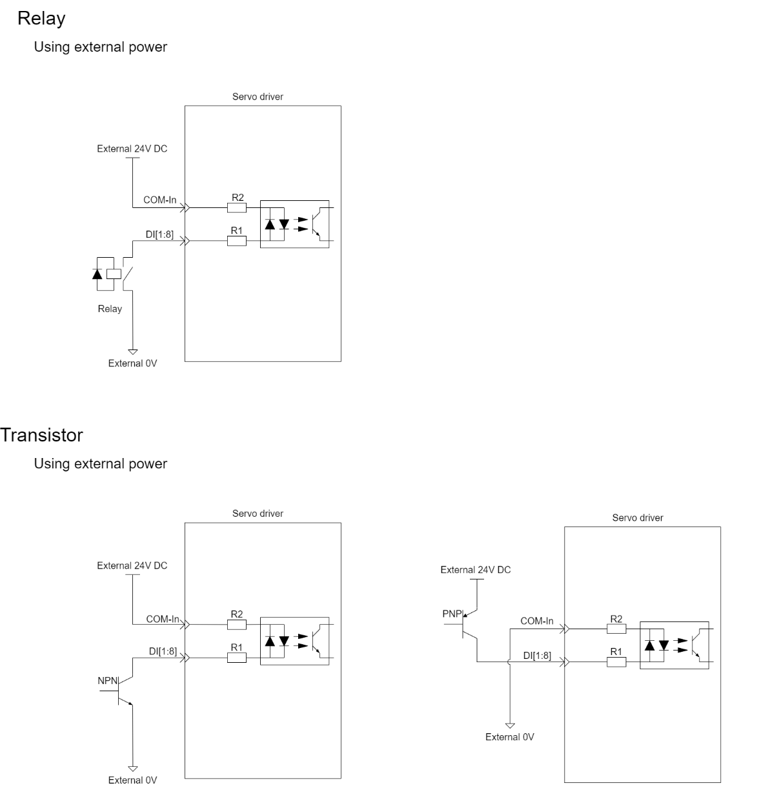
Figure ‎6-1. Digital inputs circuitry

Digital Output Circuitry
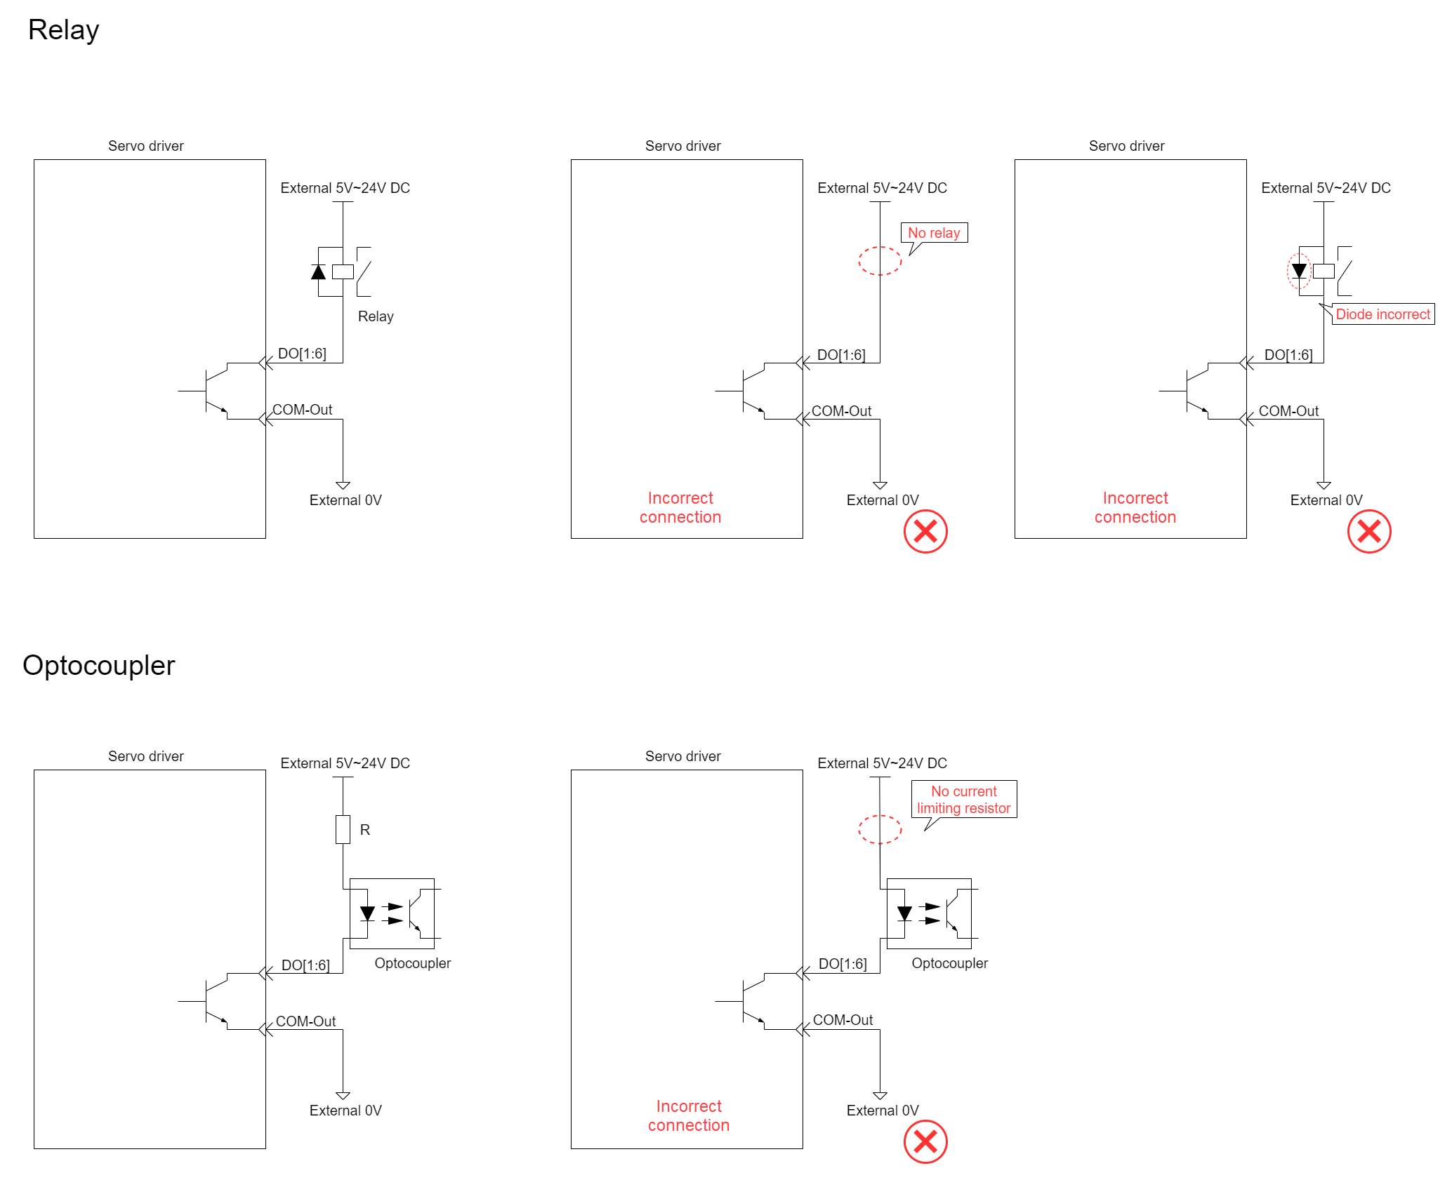
Figure ‎6-2. Digital outputs circuitry

Motor Brake Circuitry
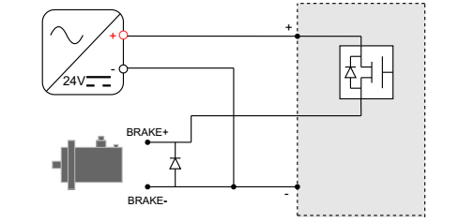
Figure ‎6-3. Motor brake circuity

ServoStudio+
ServoStudio+ is web-based software for setting motor parameters and configuring the smartPX drive.

Software Installation
ServoStudio+ is compatible with Windows 10 and later operating systems. If you require assistance with an older version of Windows, contact Servotronix Technical Support.
Download the ServoStudio+ software installation file (ServoStudio+_3.7.x.MSI) from the Servotronix website [LINK], or contact Technical Support.
Run the file.

Activation
- Activate ServoStudio+ from the desktop icon or the Start menu.
- Log in to the system:
Default username: admin
Default password: ADMIN
It is recommended that you change these credentials after logging in for the first time. User names and passwords can be modified in Settings > User Manager.
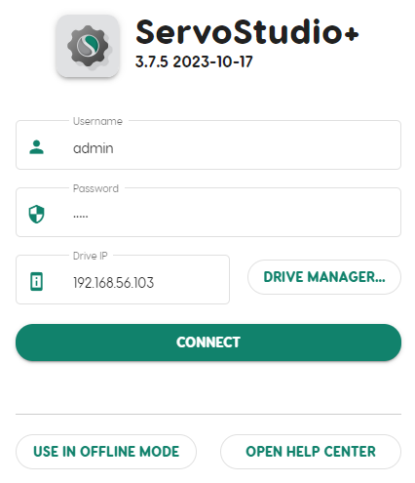
Figure ‎7-1. Login
- To activate ServoStudio+ from your desktop or tablet, you need the IP address of your smartPX. The drive is factory-configured with default address: 192.168.57.100.
Contact your IT manager to ensure that your PC is on the same network.
Enter the drive IP address, and click Connect.
Note | Some ServoStudio+ functions are available without a connection to an actual drive. If you select Use in Offline Mode, the software will start without requiring login authentication.

- ServoStudio+ opens to the home screen.
Axes should be disabled during the basic configuration. If an axis icon is lit (green), it indicates the axis is enabled.
To disable an axis, do either of the following:
- Click the enable/disable button (the POWER icon) in the toolbar at the top of the ServoStudio+ window.
- Click the axis number in the toolbar. Then use the axis toggle button in the axes pane.
Axis color | Meaning
White | Axis disabled
Green | Axis enabled
Yellow | Axis disabled with a warning
Red | Axis disabled with a fault
Green/Yellow split | Axis enabled, with a warning

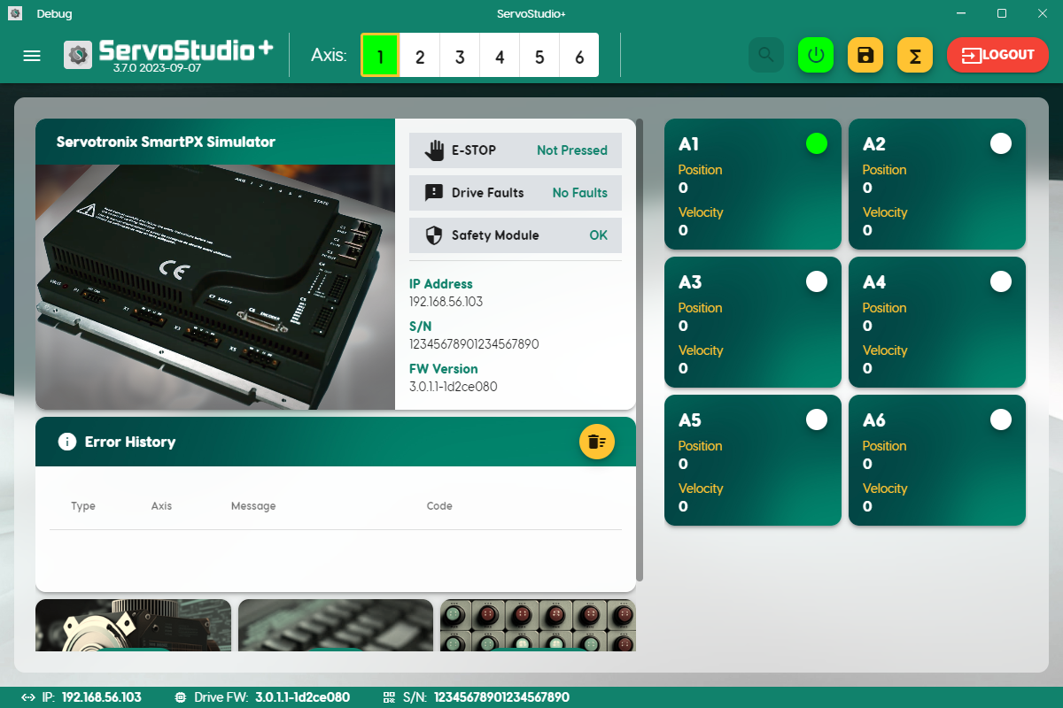
Figure ‎7-2. Home screen
- Open the ServoStudio+ navigation menu.
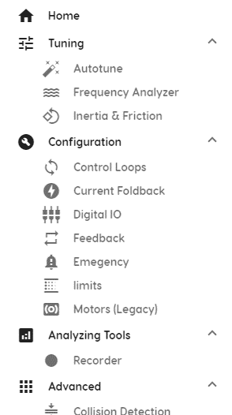
Figure ‎7-3. Navigation menu

Parameter Values
The first time a new drive is connected to ServoStudio+, the software displays the drive’s factory-defined (default) parameter values.
ServoStudio+ reads and displays values from the drive RAM.
- After you edit a parameter value, press Enter, or press Tab to move the next field. The new value is sent to the drive RAM, and an update message is displayed.
- To save parameter values to the drive’s non-volatile memory at any time, press the Save button on the ServoStudio+ toolbar. If not saved, modified parameter values are lost upon power cycle.
- To save and load parameter values to and from PC files, go to ServoStudio+ Settings > File Manager.

Drive Configuration
This section describes the basic steps for configuring the drive system using the ServoStudio+ interface.

Motors
The Motor screen allows you to select a motor from ServoStudio+ databases. When you select the motor family and model number, ServoStudio+ sets the appropriate motor and feedback parameters.
ServoStudio+ contains two databases of motor settings.
- The ServoStudio+ Library contains a database of motors already defined and supported by Servotronix. These motor settings cannot be modified by users.
- The User Library contains all other motors defined by users.

Load Motor Parameters
To load a set of motor parameters:
- In ServoStudio+, select Configuration > Motors.
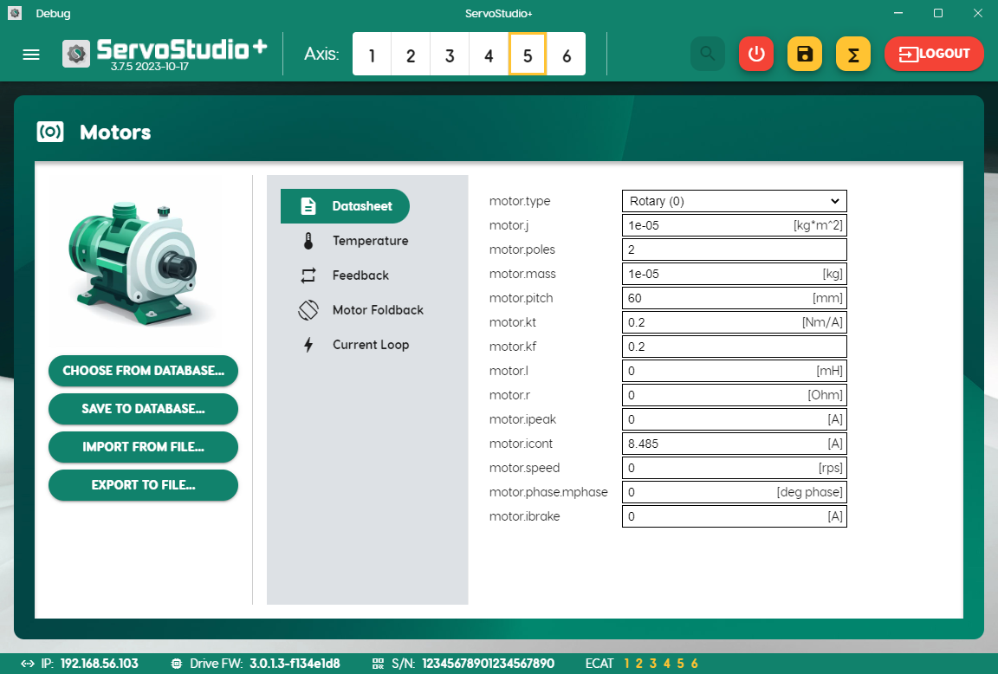
Figure ‎8-1. Motors
Choose from Database | Opens a menu that lets you select a motor from either the ServoStudio+ library or the User library.  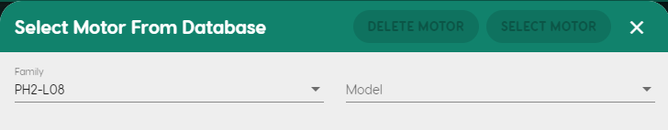
Import from File | Prompts you to load motor parameters to ServoStudio+ from a JSON file.

- Select an axis from the menu bar at the top of the ServoStudio+ screen.
- Select a motor from one of the ServoStudio+ motor libraries.
- Select Choose from Database.
- Select a motor from the Family and Model lists.
Alternately, select a motor parameter file.
- Select Import from File.
- Select the JSON file containing the required motor parameters.
ServoStudio+ loads and displays the appropriate motor and feedback parameters.

Modify Motor Parameters
To modify parameter values.
- Click in a parameter field, and enter a new value.
The modified field is highlighted, and you are prompted to save or discard the changes.
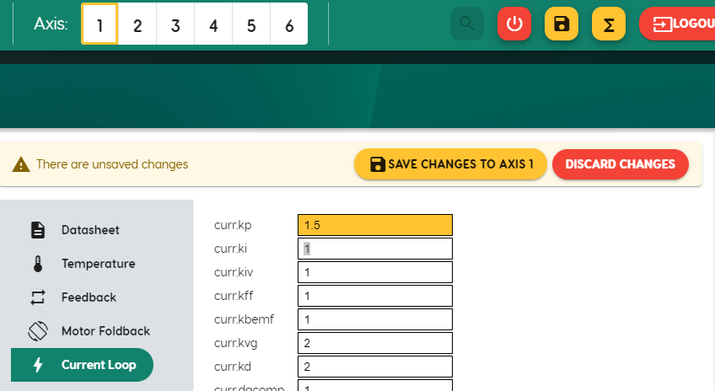
Figure ‎8-2. Save changes to axis (saves parameter in drive)
- Select Save Changes to Axis n.
Save Changes writes the new parameter values to the drive, but does not save the parameter values to the database or a file.

Copy Parameter Values to Another Motor
To copy parameter values from one motor to another:
- With modified parameter fields highlighted, select the number of the axis you want to copy to.
- Select Save Changes to Axis.

Save Motor Parameters
Save to Database | Saves motor parameter settings to the database. Does not write to the drive.  - New. When modifying parameter values of a motor in the ServoStudio+ motor library, you can save the changes only by defining a new motor in the User library.  - Replace Existing. You can overwrite a file in the User library.  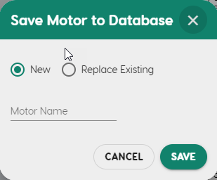
Export to File | Prompts you to save motor parameters from ServoStudio+ to a JSON file.

Feedback
- In ServoStudio+, select Configuration > Feedback.
- Open the General tab.
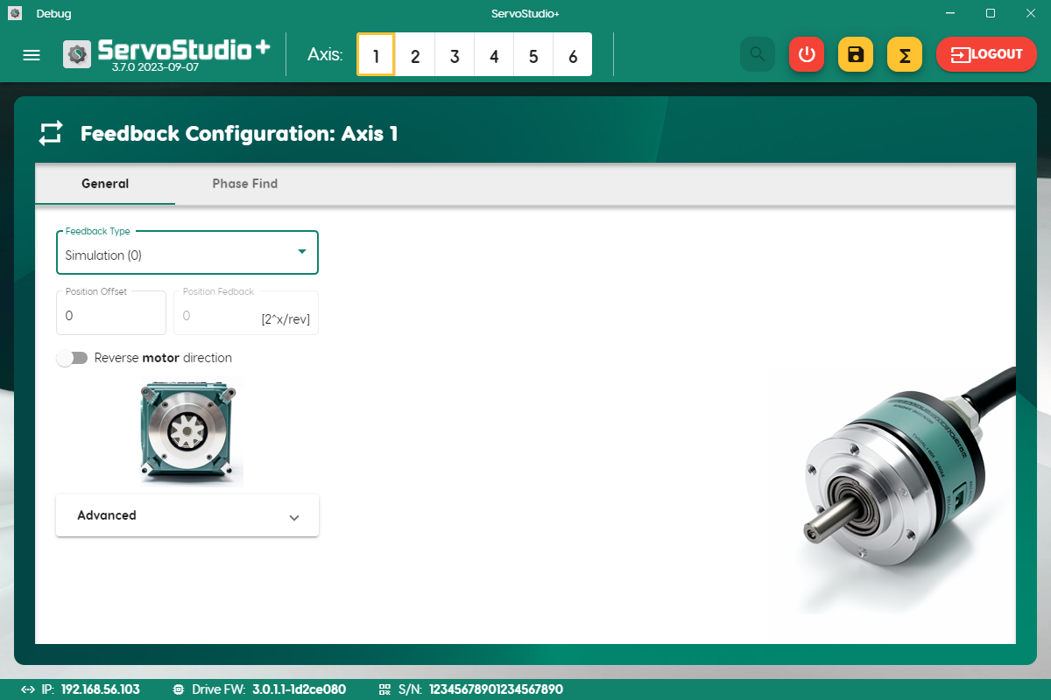
Figure ‎8-3. Feedback
- From the Feedback Type list, select the motor encoder.
- Modify other parameters as required by your application.
Feedback Type | The motor feedback device being used in the application
Position Offset | An offset value that is added to the internal cumulative position counter, to give the position feedback value.
Position Feedback | The position feedback value. Read only.
Reverse motor direction | When switched on, the values of position feedback, velocity and current are inverted, thereby reversing the direction of motor movement.

Advanced options are not required for basic configuration.
- Open the Phase Find tab.
Phase find is a procedure that initializes commutation for encoder systems.
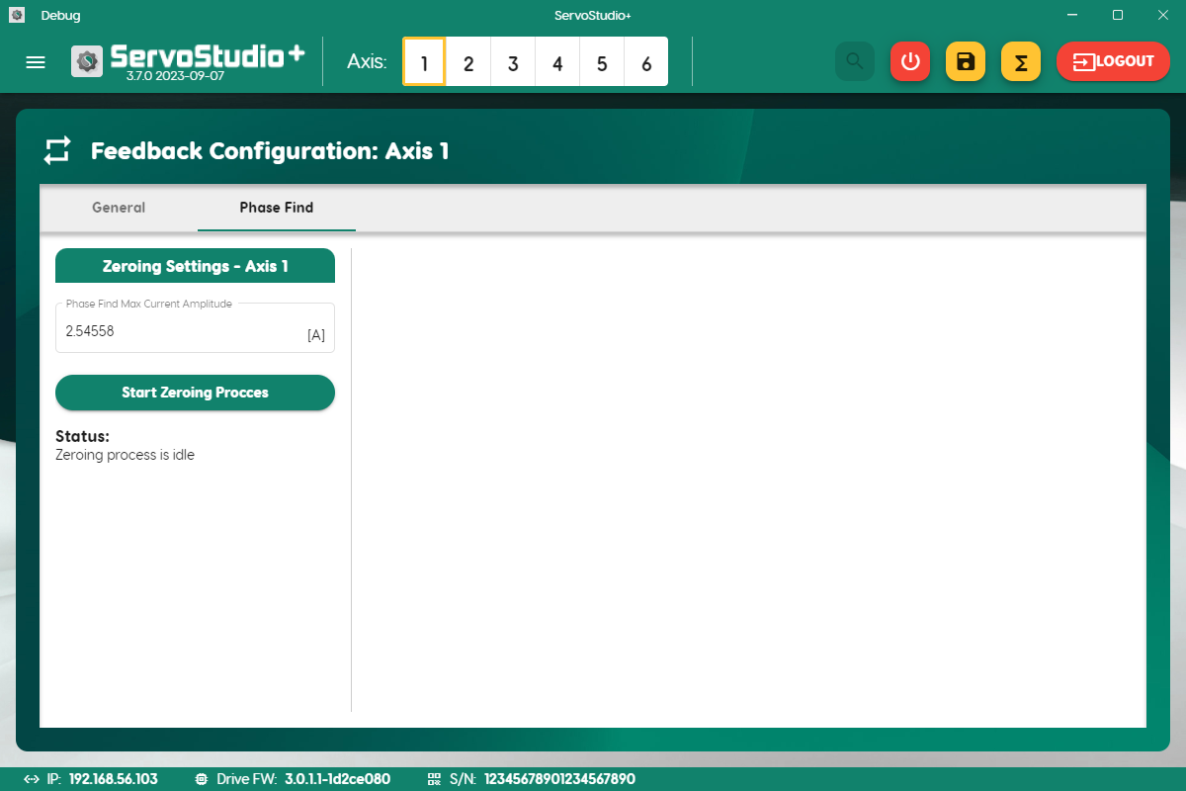
Figure ‎8-4. Phase find
ServoStudio+ for smartPX uses the zeroing process for determining the commutation offset on motors with an absolute encoder. Zeroing locks the rotor in place by passing a fixed current through two phases.
- Confirm or modify the value of Phase Find Max Current Amplitude.
Phase Find Max Current Amplitude | The fixed current used for the zeroing procedure.

- Select Start Zeroing Process.
When zeroing is activated, the drive rotates and locks the motor at the fixed electrical angle with a fixed current. Locking occurs after stopping briefly at a temporary location to overcome static friction, or after starting at an electrical angle 180° away from the final locked position.
The number of motor electrical cycles per one mechanical revolution is equal to the number of pairs of magnets. Each pair of magnets in the motor creates a 0—360 degree electrical cycle. Therefore, if the motor has 8 individual magnetic poles, the motor can be locked at four different places in one mechanical revolution.
- When zeroing is complete, a new motor phase is found. ServoStudio+ prompts you to save the new value.
Repeat for each axis.

Limits
- In ServoStudio+, select Configuration > Limits.
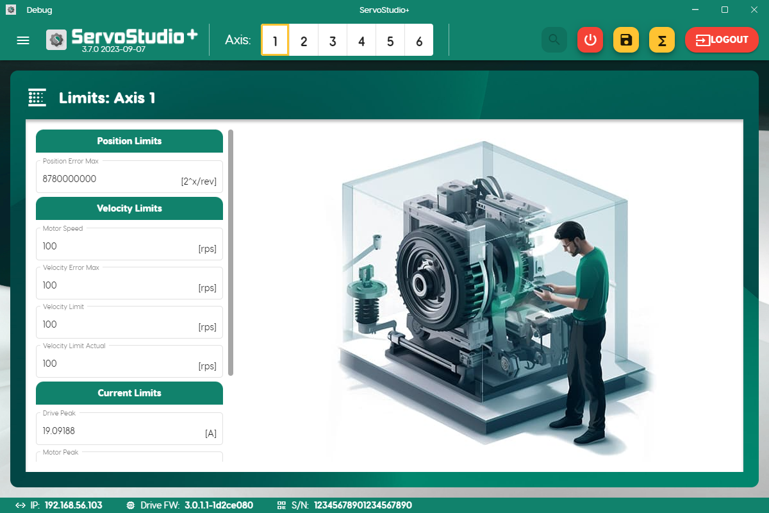
Figure ‎8-5. Limits
- Modify the values for position, velocity and current limits as required by your application.
Position Limits
Position Error Max | The maximum position error value that does not produce a fault.

Velocity Limits
Motor Speed | The maximum motor speed, according to the motor datasheet.
Velocity Error Max | The maximum velocity error value that does not produce a fault.
Velocity Limit | The maximum (user-defined) velocity limit.
Velocity Limit Actual | The actual velocity limit for the application, which is the lowest (minimum) value of all velocity limit inputs, such as motor speed and velocity limit (user limit).

Current
Drive Peak (Max) | The peak (max) current of the drive axis.
Motor Peak (Max) | The peak (max) current of the motor, according to the motor datasheet.
Current Limit | The maximum (user-defined) current limit
Current Limit Actual | The actual current limit for the application, which is the lowest (minimum) value of all current limit inputs, such as drive peak, motor peak, and current limit (user limit).

Repeat for each axis.

Digital I/Os
The Inputs and Outputs panes enables you to configure the functionality and polarity of the digital inputs and outputs, and to monitor the state of all digital inputs and outputs.
ServoStudio+ displays the actual number of I/Os and brakes connected to the drive, as configured in the drive firmware.
The Brakes pane in the Digital I/Os screen enables you to activate brake functionality and to monitor the state of all brakes. Brakes are controlled by dedicated outputs as configured in the drive firmware.
- In ServoStudio+, select Configuration > Digital I/Os.
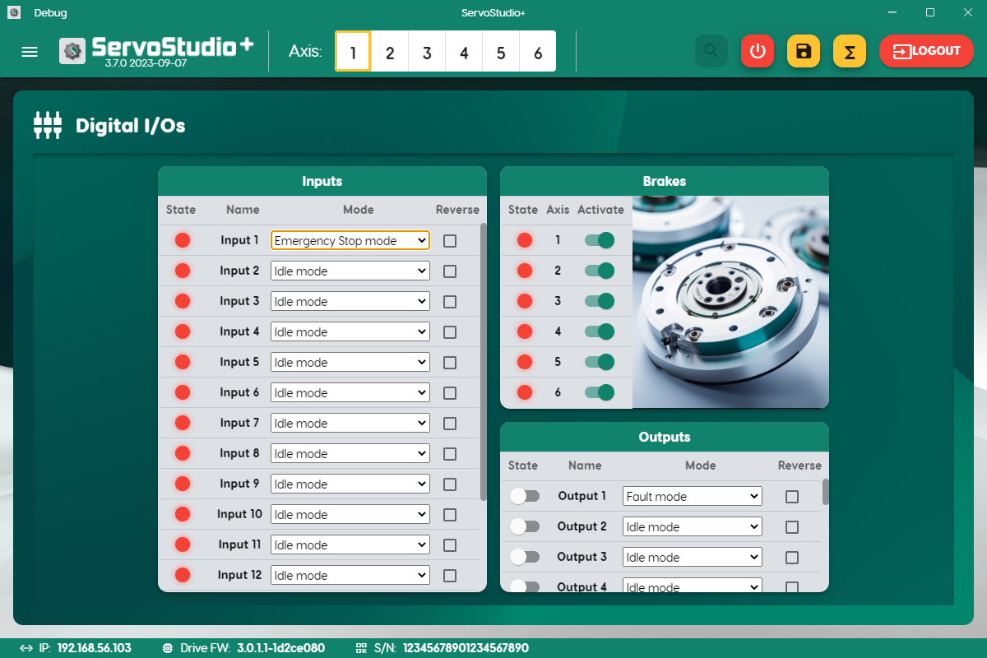
Figure ‎8-6. Digital I/Os
- Set the modes for the defined inputs and outputs in your application.
Input and output mode definitions are specified in the drive firmware.
Digital input modes:
- Idle.
- Emergency stop.
- PLS. Positive limit switch.
- NLS. Negative limit switch.
- Home switch.
Digital output modes:
- Idle.
- Fault.

Autotune
Caution! Tuning is potentially dangerous. Before starting any tuning routines, make sure there are no persons or obstructions within the motion envelope. Also make sure the emergency stop button is within your reach.

- In ServoStudio+, select Tuning > Autotune.
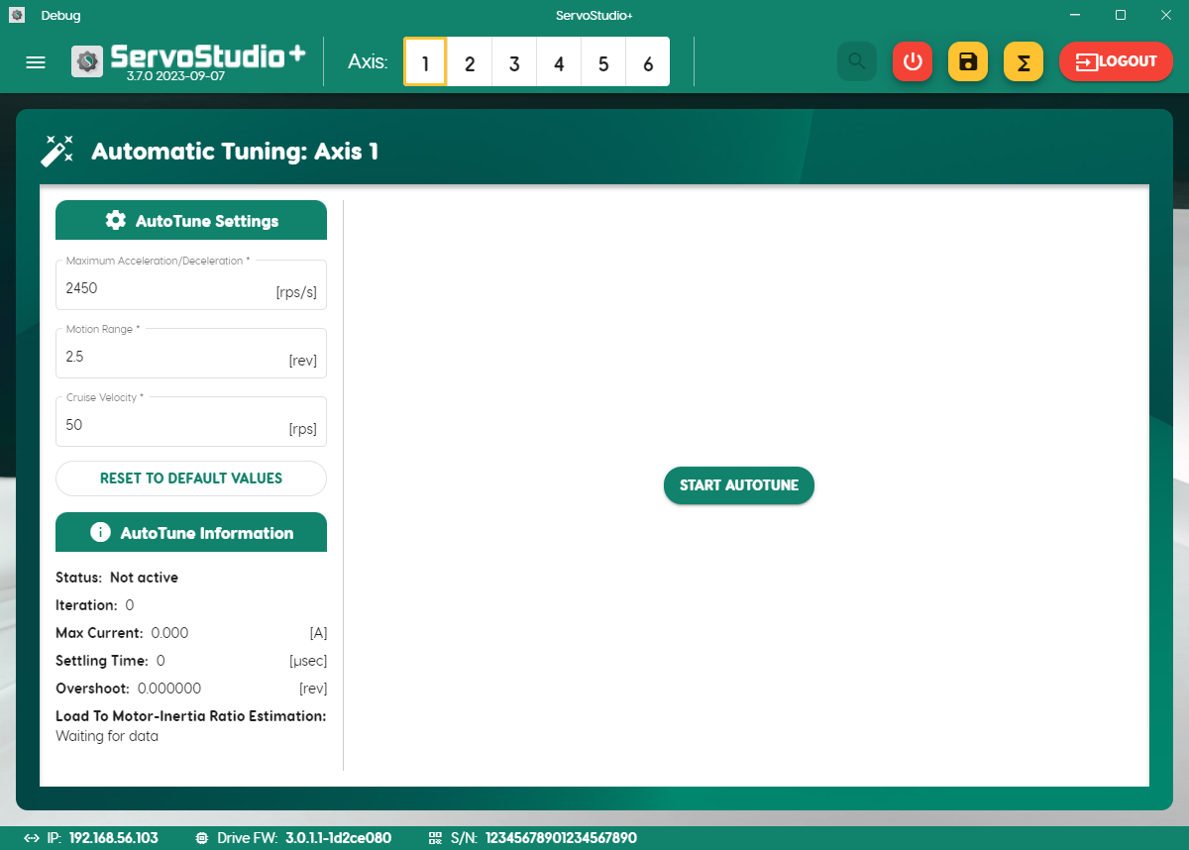
Figure ‎8-7. Autotuning
- Make sure the displayed values in Autotune Settings are suitable for your application.
Autotune Settings
Maximum Acceleration/ Deceleration | User defined maximum acceleration/deceleration value.
Motion Range | User defined number of motor revolutions.
Cruise Velocity | User defined speed.

- Click Start Autotune.
- When Autotune is complete, options are displayed for testing controller performance.
- Select Target Position, Cruise Velocity and Acceleration.
- Press Move & Plot.
- View the results on the graph.
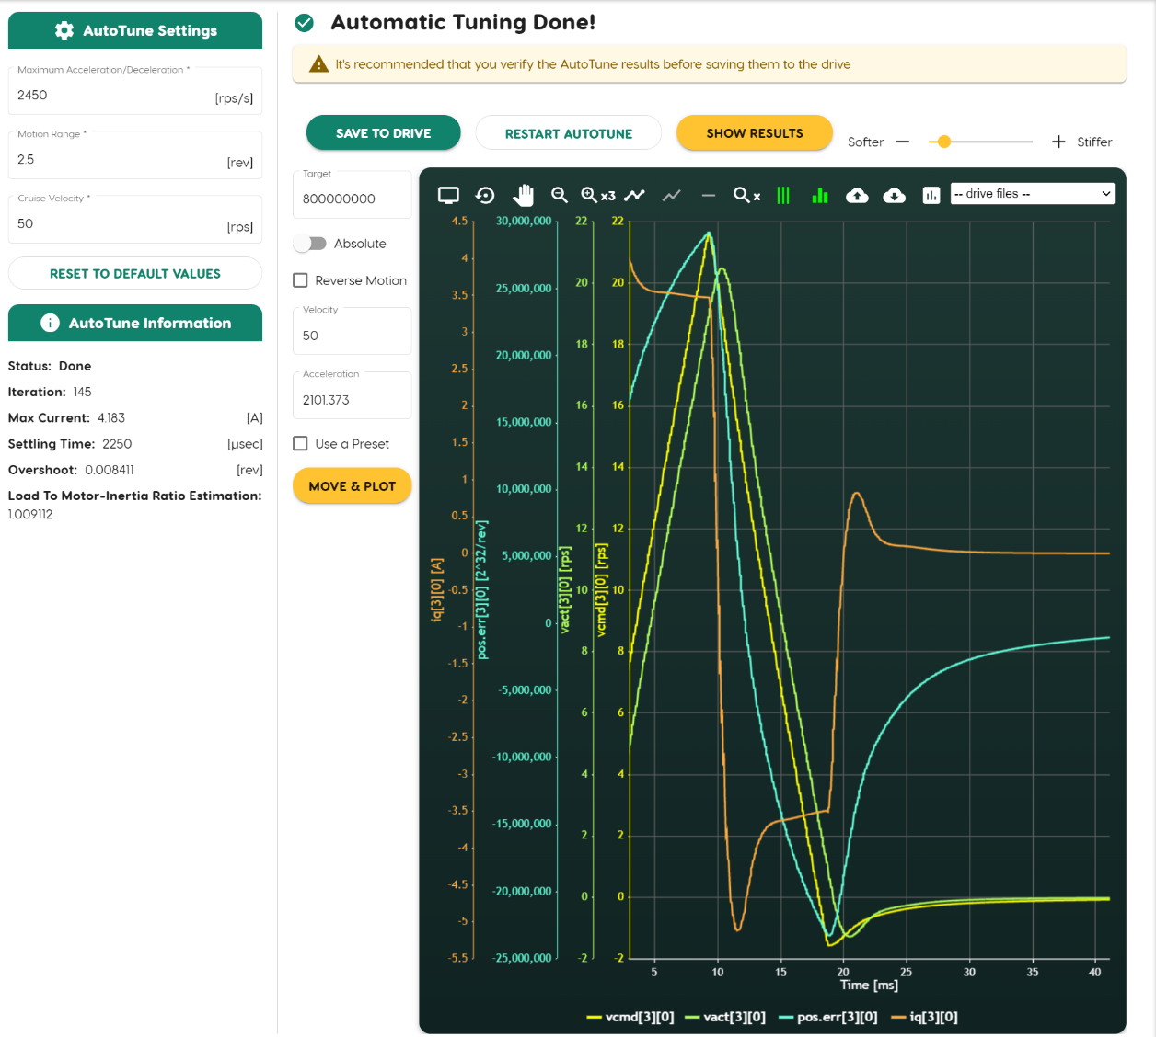
Figure ‎8-8. Autotuning test results
- If the results are satisfactory, press Save to Drive.
If the results are not satisfactory, use the Softer/Stiffer slider in the upper right corner of the screen to adjust the controller performance.
- If necessary, restart the autotuning process.
- When you are satisfied with the Autotuning test results, save the parameters to the drive.
- You can now proceed to optimize drive parameters for your particular application.

Control Loop
Note | Control loop manipulation is intended for users with suitable training and expertise.  The basic drive configuration does not require any changes in control loop parameters.

The first time a new drive is connected to ServoStudio+, the software displays the drive’s factory-defined (default) values for the control loops.
- In ServoStudio+, select Configuration > Control Loops.
- Review the Current Loop, Velocity Loop, and Position Loop tabs.
Make sure the displayed settings are suitable for your application.
- Modify the values for the control loops as required by your application.

Position Loop
The smartPX has a linear, proportional (P) controller with feedforward.
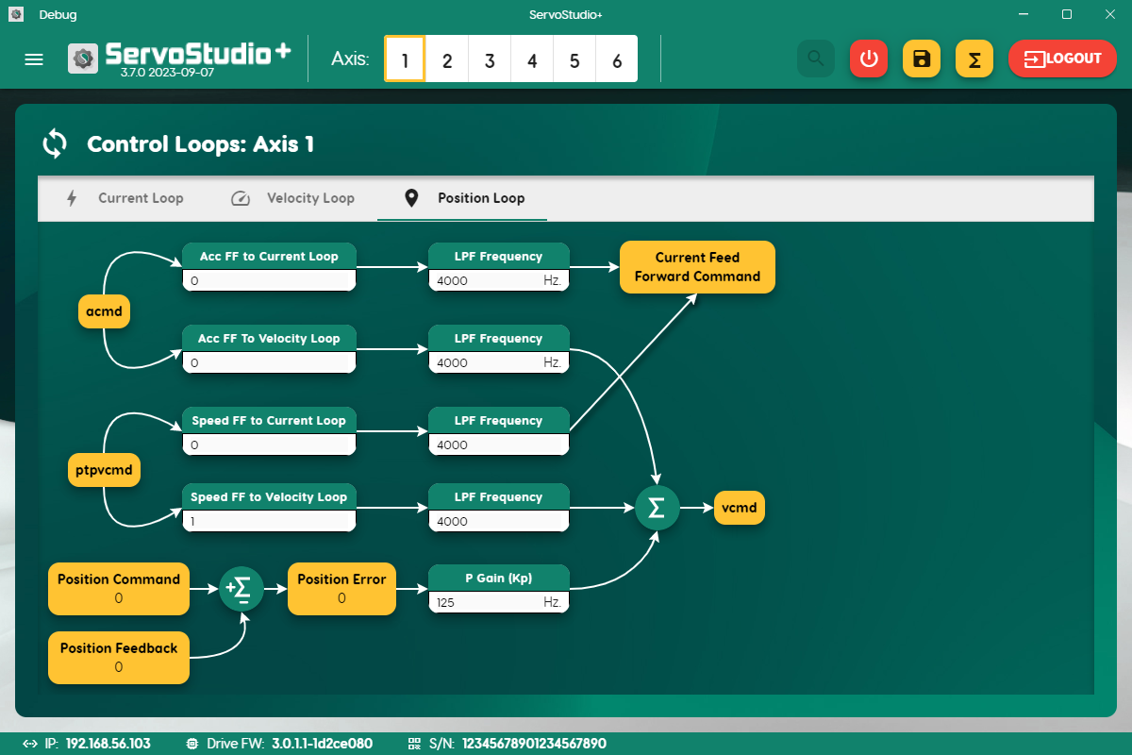
Figure ‎8-9. Position control loop

Current Loop
The current control loop tuning is derived from the motor properties and the bus voltage.
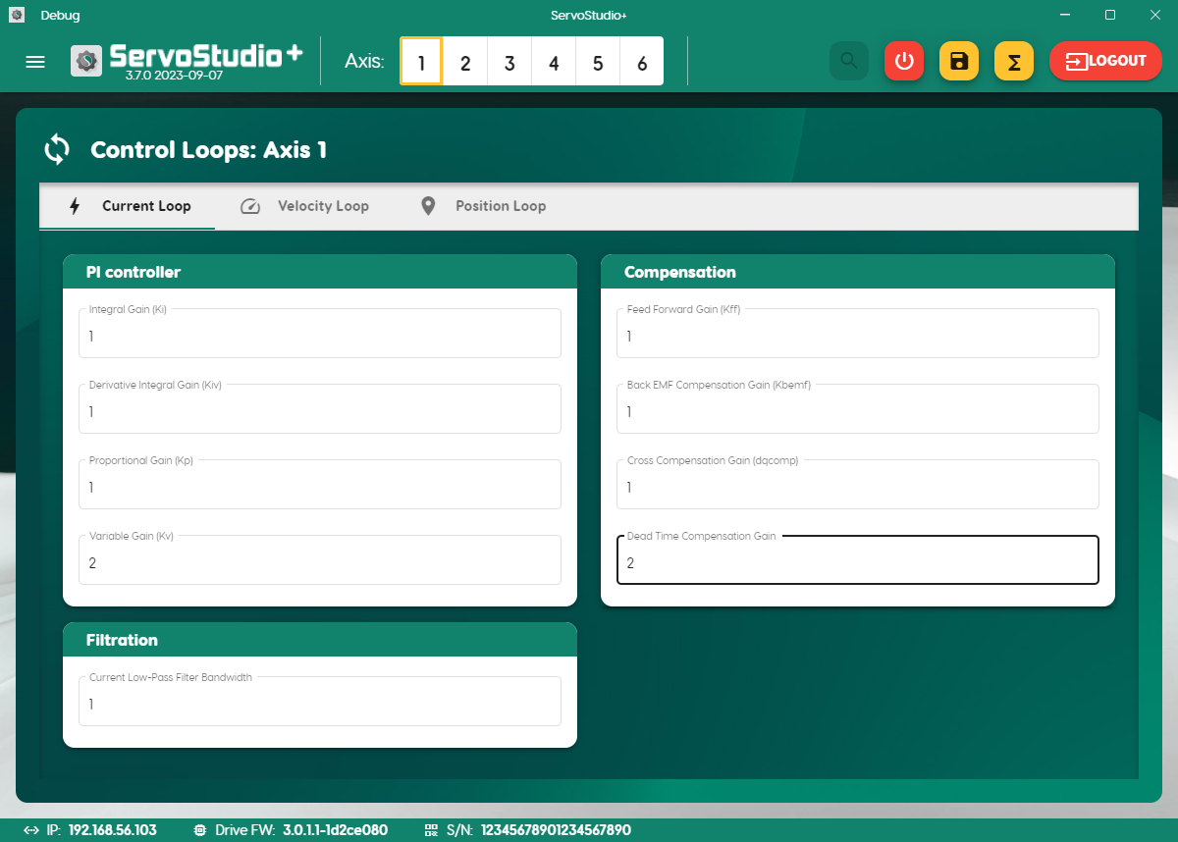
Figure ‎8-10. Current control loop
There is no need to manipulate values in the Current Loop screen, unless instructed to do so by Technical Support.

Velocity Loop
The smartPX has two velocity controllers:
- Pseudo derivative feedback and feedforward (PDFF) controller
The PDFF controller has an integral gain and a proportional gain, with the addition of feedforward.
When an application requires maximum responsiveness, less integral gain is required, and the PDFF feedforward value can be set to a higher value. When an application requires maximum low-frequency stiffness, the feedforward value is lowered, which allows much higher integral gain without inducing overshoot. This will also cause the system to be slower in responding to the command. A mid-range feedforward value is usually suitable for motion control applications.
- Standard pole placement (PP) controller
The PP controller uses three parameters for tuning the control loop: bandwidth, gain and tracking factor.
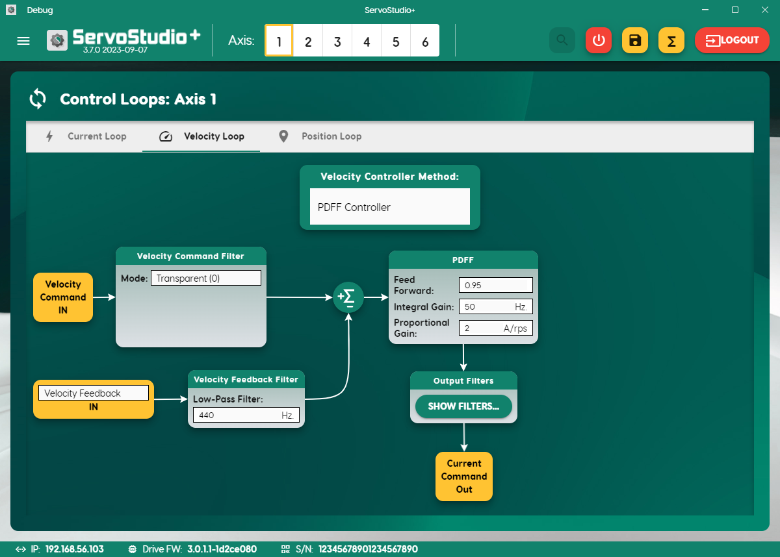
Figure ‎8-11. Velocity control loop

Upgrade Drive Firmware
- Download the firmware file (MAXX_3.0.x.x.ZIP) from the Servotronix website [LINK], or contact Technical Support.
- In ServoStudio+, go to Settings > Firmware Update.
- In the Load File field, select the new firmware ZIP file, and click Upgrade.
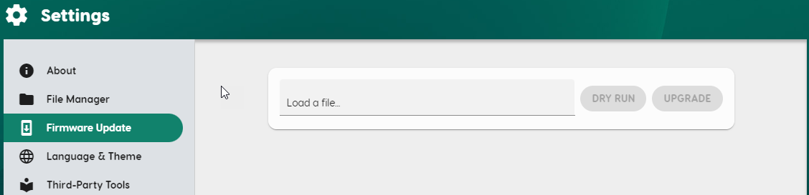
Figure ‎8-12. Firmware update

Warnings and Faults

Warnings
Warning Code | Message | Description | Likely Cause/s | Action Required
0x00400402 | Velocity loop parameter changed. Vel.execute is required. | The vel.execute command is required after the value of a velocity loop parameter is modified | One or more velocity control loop parameters was changed | - Set vel.execute<axis>=1
0x00400701 | Brake release taking too long | Brake release time exceeds the defined timeout value | Took too much time to release the brake. | - Check brake timeout parameter (brake.release.timeout)
0x00400f04 | Motor position feedback device reports an internal warning. | Warning from feedback device. The warning varies, depending on the specific feedback device. | Error status reported from feedback device. | - Contact Technical Support.
0x00400f05 | Motor position feedback device not responding on time warning | Problem receiving data from feedback device (sensAR) | Incorrect configuration of encoder type | - Check feedback type configuration (mfb.type)  - Contact Technical Support.
0x00401205 | Interpolation error.  Check Feedback Position Resolution. | 10% of interpolation results are incorrect | Problem with feedback device | - Check feedback device type  - Validate actual position value (pfb)
0x00401603 | Position loop parameter changed. Pos.execute is required. | The pos.execute command is required after the value of a position loop parameter is modified | One or more position control loop parameters was changed | - Set pos.execute<axis>=1
0x00401a13 | Default drive configuration | Cannot load parameters. Default configuration used. | - New drive in use  - The parameter file (servo.dat) was deleted from the drive | - Create/ load parameters file
0x00401c02 | Phase A Current Sensor Out Of Range | Current sensor reported value out of range | Current sensor configuratioon not within range | - Check current sensor configuration  - If the warning persists, contact Technical Support.
0x00401c04 | Phase C Current Sensor Out Of Range | Current sensor reported value out of range | Current sensor configuratioon not within range | - Check current sensor configuration  - If the warning persists, contact Technical Support
0x00401f01 | Gainset parameters changed. Vargains.execute is required. | The vargains.execute command is required after the value of a gainset parameter is modified | Gainset configuration parameter was changed | - Set vargains.execute<axis>=1
0x00401f02 | Could not find suitable Gainset | Gainset not found in the current variable gains configuration | Variable gains is active and current position is incompatible with configured gainset | - Check variable gainset configuration  - Check axis position  - If required, disable variable gains function
0x00401f03 | Gainset is not in use or cannot be activated | Suitable gainset not in use (configured gainset) or cannot be used (problem setting gainset) | Gainset configured with inuse set to zero | - Check parameter vargains.active and vargains.inuse  - Check gainset configuration
0x00402507 | Phase Find current command is insufficient | Actual current command is less than phase find current command, but not equal to zero | Ilim value is less than the phase find current set by the user (phasefind.icmd). | - Reduce phase find current command  - Increase Ilim, if defined by the user
0x00402508 | Phase Find auto is on – if axis is enabled, phase find will start | Warning after activation of Phase Find | Phasefind.auto is 1, and the axis has not been enabled yet after power-up | - If Automatic Phase Find after drive power up is desired, no action is required. After the axis is enabled, phase find will start and the warning will disappear  - If Automatic Phase Find is not desired, disable it (phasefind.auto=0)
0x00402701 | uwSwap was executed. Zeroing is required. | When uwSwap is active, zeroing is required. | Phase Swap was performed | - Execute the zeroing process
0x00402801 | Field-Weakening config failed | Field-weakening not compatible with motor parameters | Field-weakening is not possible for the defined motor parameters. | - Make sure motor parameters (peak current, poles, kt, inductance, resistance) are all correct.
0x00409804 | Motor position feedback device reports counter overflow | Warning from multiturn feedback device | Error status reported from feedback device. | - Contact Technical Support
0x00409808 | Motor position feedback device reports battery alarm | Warning from multiturn feedback device | - Low supply battery voltage  - The battery does not exist | - Check/ change battery feedback device  - If the warning persists, contact Technical Support
0x0040d403 | Vact configuration changed. Vel.execute is required. | The vel.execute command is required after the value of a velocity loop parameter is modified | One or more velocity control loop parameters was changed | - Set vel.execute<axis>=1
0x0040d405 | Cannot calculate MVE – no Vact signal | No velocity feedback signal (Vact) received for Model Velocity Error calculation | Velocity feedback is disabled. This is extremely unusual, unless velocity feedback was deliberately disabled. | - Enable Velocity feedback, or change opmode such that it is enabled (for example, switch to position opmode). Make sure the internal opmode matches the opmode (that is, not in phase find/ homing/ other).
0x0040d406 | Cannot calculate MVE – no Vobs signal | No Velocity feedback signal (Vobs) received for Model Velocity Error calculation | Velocity observer is disabled | - Design and enable a velocity observer using the GUI. To validate, make sure that vact.Kalman.L.execute=1 after design.
0x0040d407 | Collision detection mode is disabled | collision.response is not zero but collision.detect.mode is zero (not configured) | Collision.response is not 0, but collision.detect.mode is 0 | - Enable collision detection; set collision.detect.mode to a non-zero value
0x0040dc03 | Regen Resistor Overload Warning | Regen resistor has been activated excessively within the last 5 seconds. It exceeds the maximum average power dissipated. | The regen resistor is overloaded | - Check regen resistor configuration  - Check appropriation regen resistor for the setup
0x0040dd01 | IPM OT | The actual temperature value is higher than the minimum (warning) threshold. | The actual IPM temperature value is greater than minimum threshold (temp.ipm.flt.low) | - Check device temperature  - Check threshold parameter  - Check actual temperature parameter (temp.ipm)
0x0040dd03 | Motor OT | The actual temperature value is higher than the minimum (warning) threshold. | The motor temperature value is greater than minimum threshold (temp.motor.flt.low) | - Check motor temperature  - Check threshold parameter  - Check actual temperature parameter (temp.motor)
0x0040de01 | Ambient OT | The actual temperature value is higher than the minimum (warning) threshold. | Power/ ambient device temperature is too high | - Check ambient temperature  - Check cooling device, if exists
0x0040de03 | Device MPU OT | The actual temperature value is higher than the minimum (warning) threshold. | - Device core temperature too high  - Incorrect threshold configuration  - Problem reading device sensor | - Check device temperature  - Check threshold parameter  - Check actual temperature parameter (temp.cpu.mpu)
0x0040de05 | Device CORE OT | The actual temperature value is higher than the minimum (warning) threshold. | - Device core temperature too high  - Incorrect threshold configuration  - Problem reading device sensor | - Check device temperature  - Check threshold parameter  - Check actual temperature parameter (temp.cpu.core)
0x0040de07 | Device IVA OT | The actual temperature value is higher than the minimum (warning) threshold. | - Device core temperature too high  - Incorrect threshold configuration  - Problem reading device sensor | - Check device temperature  - Check threshold parameter  - Check actual temperature parameter (temp.cpu.iva)
0x0040de09 | Device DSP OT | The actual temperature value is higher than the minimum (warning) threshold. | - Device core temperature too high  - Incorrect threshold configuration  - Problem reading device sensor | - Check device temperature  - Check threshold parameter  - Check actual temperature parameter (temp.cpu.dsp)
0x0040de0b | Device GPU OT | The actual temperature value is higher than the minimum (warning) threshold. | - Device core temperature too high  - Incorrect threshold configuration  - Problem reading device sensor | - Check device temperature  - Check threshold parameter  - Check actual temperature parameter (temp.cpu.gpu)
0x00541601 | Position loop design failed – MKT is zero | Motor constant parameter value is zero | Motor constant parameter is set to zero value | - Configure motor constant parameter (motor.kt)
0x00541a03 | IPM Warning | IPM fault was reported. Enable command required to release latch | IPM fault was reported | - Set enable command, if possible
0x00541a12 | 15ISO out of range | The actual 15ISO value is greater than the maximum threshold or lower than the minimum threshold. | Problem reading device power board | - Power cycle the drive  - If the error persists, contact Technical Support.

Faults
Fault Code | CAN Error Code | Disable Action | Message | Description | Likely Cause/s | Action Required
0x00040302 | 0x8381 | StopOnPath | High IQ Current Detected | Actual Iq current exceeds the defined threshold  Iq current is greater than user current limit (curr.lim.user) + drives peak current (drive.ipeak)*0.2 for more than 1[ms] | - Unstable control loop  - Not correct motor parameters, limits | - Check limits and setup configuration  - Check control loops tuning
0x00040401 | 0x8482 | StopOnPath | Velocity Error Deviation Exceeded | The difference between velocity command and actual velocity is greater than maximum velocity error | - Incorrect motor parameters configuration  - Incorrect control gains  - Limit configuration too low | - Check the drive limits (position, velocity, current)  - Check control gains
0x00040d00 | 0x2310 | StopOnPath | Motor foldback value is less than threshold value | Motor fold current dropped below the motor fold current fault threshold | - Incorrect motion profile for the application  - Control gains, loads for axis  - Incorrect motor parameters configuration | - If excessive load during motion: reduce payload, change motion profile (acc/ dec)  - Check control gains, loads  - Check motor parameters  - Check brakes release, if exists  - Check foldback threshold parameter (motor.foldback.flt.thresh)
0x00040e00 | 0x2311 | StopOnPath | Drive foldback value is less than threshold value | Drive fold current dropped below the drive fold current fault threshold | - Excessive load, acceleration/ deceleration in the motion profile for the application  - Incorrect drive configuration parameters | - If excessive load during motion: reduce payload, change motion profile  - Check control gains, loads  - Check drive parameters  - Check foldback threshold parameter (drive.foldback.flt.thresh)  - If the error persists, contact Technical Support
0x00041202 | 0x8480 | StopOnPath | Generated Vcmd exceeded velocity limit | Generated velocity command exceeded velocity limit | Configuration parameter vlim is less than maximum than maximum velocity limit it motion controller. | Check velocity limit in the motion controller and drive. Limit must be equal in both or higher in the drive.
0x00041203 | 0x8483 | StopOnPath | Generated Acmd exceeded acceleration limit | Generated acceleration command exceeded acceleration limit | Configuration parameter uint.acc.max is less than maximum acceleration limit in motion controller. | Check acceleration limit in the motion controller and drive. Limit must be equal in both or higher in the drive.
0x00041204 | 0x8580 | StopOnPath | Excessive number of extrapolations | The number of extrapolations performed exceeds the maximum threshold | Drive did not receive a motion command from motion controller more than 10 times. | - Verify the EtherCAT messages transmission rate  - Verify an EtherCAT connection
0x00041602 | 0x8611 | StopOnPath | Excessive deviation in position error | The difference between the position command and the actual position exceeds the maximum position error | - Control gains not acceptable for axis  - Incorrect motor parameters configuration  - Position error deviation threshold configuration | - Check control gains, loads  - Check brakes release, if exists  - Check position error deviation threshold configuration (pos.err.max)
0x00041a0c | 0x2386 | StopOnPath | Deadtime phase U fault | The delay time between high and low PWM signals is less than the deadtime value calculated by the FPGA. | Incorrect configuration/ functionality deadtime for phase U | - Check the deadtime setting parameter (drive.deadtime.watchdog)  - If the error persists, contact Technical Support
0x00041a0d | 0x2387 | StopOnPath | Deadtime phase V fault | The delay time between high and low PWM signals is less than the deadtime value calculated by the FPGA. | Incorrect configuration/ functionality deadtime for phase V | - Check the deadtime setting parameter (drive.deadtime.watchdog)  - If the error persists, contact Technical Support
0x00041a0e | 0x2388 | StopOnPath | Deadtime phase W fault | The delay time between high and low PWM signals is less than the deadtime value calculated by the FPGA. | Incorrect configuration/ functionality deadtime for phase W | - Check the deadtime setting parameter (drive.deadtime.watchdog)  - If the error persists, contact Technical Support
0x00041b01 | 0x7386 | StopOnPath | EtherCAT SYNC Jitter too high | SYNC signal jitter greater than the threshold | The actual SYNC jitter is greater than the EtherCAT SYNC0 jitter limit (fb.sync.jitter.limit). | - Check cable/ connector EtherCAT  - Check SYNC0 jitter limit (fb.sync.jitter.limit)
0x00041b02 | 0x818d | StopOnPath | Packet lost | Consecutive count for packet loss is greater than the maximum threshold | Issue in EtherCAT line communication | Check EtherCAT cable master/ slave
0x00041b03 | 0xf080 | StopOnPath | Fieldbus - Drive is active but not in Operational | Drive in Enabled state but communication state changed from OP to PREOP/ SAFEOP | Communication is down but drive remains in Enabled state | - Change motion controller communication state to OP
0x00042102 | 0x7091 | StopOnPath | Emergency Stop Issued | Emergency Stop digital input is activated | Emergency Stop button is in active state | - Release the E-stop button  - Change, if require, digital input mode
0x00042602 | 0x0000 | StopOnPath | Hardware positive limit switch is open | Positive hardware limit switch was activated | Active state of input configured as positive limit switch | - Change position of motor against the sensor  - Deactivate digital input  - Change, if require, digital input mode
0x00042603 | 0x0000 | StopOnPath | Hardware negative limit switch is open | Negative hardware limit switch was activated | Active state of input configured as negative limit switch | - Change position of motor against the sensor  - Deactivate digital input  - Change, if require, digital input mode
0x0004d402 | 0x8481 | StopOnPath | Velocity over speed | Actual velocity exceeded 125% of maximum velocity on 4 consecutive samplings | - Incorrect motor parameters configuration  - Incorrect control gains  - Limit configuration too low | - Check the drive limits (position, velocity, current)  - Check control gains
0x0004dc01 | 0x3120 | StopOnPath | Under Voltage Fault | The bus voltage is below the minimum value | - Power supply loss, poor power supply  - Excessive load during motion | - Check mains voltage  - If excessive load during motion: reduce payload, change motion profile (acc/ dec)  - If the error persists, contact Technical Support
0x0004dd02 | 0x4080 | StopOnPath | IPM over-temperature | Actual temperature greater than the maximum threshold | The actual IPM temperature value is greater than the maximum threshold (temp.ipm.flt.high) | - Check device temperature  - Check threshold parameter  - Check actual temperature parameter (temp.ipm)
0x0004dd04 | 0x4410 | StopOnPath | Motor over-temperature | Actual temperature greater than the maximum threshold | The actual motor temperature value is greater than the maximum threshold (temp.motor.flt.high) | - Check motor temperature  - Check threshold parameter  - Check actual temperature parameter (temp.motor)
0x0004de02 | 0x4310 | StopOnPath | Ambient OT | The actual ambient temperature value is higher than the maximum threshold | Power/ ambient device temperature too high | - Check ambient temperature  - Check cooling device, if exists
0x0004de04 | 0x4081 | StopOnPath | Device MPU over-temperature | The actual temperature value is greater than maximum threshold | - Device MPU temperature too high  - Incorrect threshold configuration  - Problem reading device sensor | - Check device temperature  - Check threshold parameter  - Check cooling device, if exists  - Check actual temperature parameter (temp.cpu.mpu)
0x0004de06 | 0x4081 | StopOnPath | Device CORE over-temperature | The actual temperature value is greater than the maximum threshold | - Device core temperature too high  - Incorrect threshold configuration  - Problem reading device sensor | - Check device temperature  - Check threshold parameter  - Check cooling device, if exists  - Check actual temperature parameter (temp.cpu.core)
0x0004de08 | 0x4081 | StopOnPath | Device IVA over-temperature | The actual temperature value is greater than maximum threshold | - Device IVA temperature too high  - Incorrect threshold configuration  - Problem reading device sensor | - Check device temperature  - Check threshold parameter  - Check cooling device, if exists  - Check actual temperature parameter (temp.cpu.iva)
0x0004de0a | 0x4081 | StopOnPath | Device DSP over-temperature | The actual temperature value is greater than the maximum threshold | - Device DSP temperature too high  - Incorrect threshold configuration  - Problem reading device sensor | - Check device temperature  - Check threshold parameter  - Check cooling device, if exists  - Check actual temperature parameter (temp.cpu.dsp)
0x0004de0c | 0x4081 | StopOnPath | Device GPU over-temperature | The actual temperature value is greater than the maximum threshold | - Device GPU temperature too high  - Incorrect threshold configuration  - Problem reading device sensor | - Check device temperature  - Check threshold parameter  - Check cooling device, if exists  - Check actual temperature parameter (temp.cpu.gpu)
0x000c0f01 | 0x73a0 | Dynamic Brake Time | Motor position feedback communication error: response timeout CRC error in response HAL failure. | Error message from feedback device. The fault is active when the status counter becomes equal to or greater than status error threshold. | - Cable of feedback device disconnected  - Incorrect configuration of feedback type  - Feedback cable not shielded | - Check feedback cable: connection, supply  - Check feedback type configuration (mfb.type)  - If the error persists, contact Technical Support.
0x000c2401 | 0xff08 | Dynamic Brake Time | Runaway Detected | Uncontrolled motor motion | - Incorrect motor parameters configuration  - Incorrect motor phases connection order | - Check motor parameters  - Check motor phases connection
0x000cd401 | 0x8484 | Dynamic Brake Time | Extreme Velocity Over Speed | Actual velocity exceeded 150% of maximum velocity on 4 consecutive samplings | - Motion command from master greater than drive velocity limit  - Motor runaway due to opposite phase angle or motion in opposite direction, or mismatched UVW  - Controller is unstable and vlim is too small. | - Check velocity limit parameter in drive (vlim)  - Check gains control loop  - Check motor phases, phase angle
0x00140301 | 0x8380 | Disable | Unstable Current Loop | Actual current on any one of the phases exceeds 125% of drive’s peak current for 10 consecutive RT cycles | - Incorrect motor parameters configuration  - Incorrect motor phases order  - Incorrect control gains | - Check the motor parameters  - If the error persists, contact Technical Support
0x00140303 | 0x2383 | Disable | Invalid Phase A Current Sensing Offset | Actual Ia current exceeds the defined threshold.  Fault prevents zero current reading while PWM is active  Phase A current exceeds 5% of drive peak current (drive.ipeak) | - Unstable current control loop  - Incorrect motor/ drive parameters  - Short circuit motor phases | - Check current control loop gains  - Check limits and setup configuration  - Check motor phases  - If the error persists, contact Technical Support
0x00140304 | 0x2384 | Disable | Invalid Phase C Current Sensing Offset | Actual Ic current exceeds the defined threshold.  Fault prevents zero current reading while PWM is active  Phase C current exceeds 5% of drive peak current (drive.ipeak) | - Unstable current control loop  - Incorrect motor/ drive parameters  - Short circuit motor phases | - Check current control loop gains  - Check limits and setup configuration  - Check motor phases  - If the error persists, contact Technical Support
0x00140700 | 0x7180 | Disable | Unexpected brake engage | The axis received brake engaged indication without request | - Motors brake cable disconnected  - Motors brake cable short circuit | - Check motors brake cable connection  - Check voltage brake measure  - Check motor
0x00140702 | 0x7181 | Disable | Brake Status Overload Fault | The FPGA reports an overload | - Short to ground  - Thermal shutdown  - Thermal swing brakes status fault | - Check brakes power supply  - If brakes not supported, disable brakes configuration
0x00140703 | 0x7182 | Disable | Brake status open load, short to battery, reverse polarity fault | The FPGA reports a fault in brakes status | - Brakes configured but not supported  - Brakes cable not connected to brakes  - Brakes short circuit  - Reverse polarity | - Check brakes power supply  - If brakes not supported, disable brakes configuration
0x00140f03 | 0x73a1 | Disable | Motor position feedback device reports an internal fault. | Error message from feedback device. Message varies, depending on the specific feedback device. | Error status reported from feedback device. | - Contact Technical Support
0x00141201 | 0x6380 | Disable | Interpolation Design Failed | Error in interpolation | Problem with EtherCAT cycle time or configuration/ sync | - Check interpolation configuration  - Check cycle time configuration  - If the error persists, contact Technical Support.
0x00141a01 | 0x2214 | Disable | Axis Over Current | Short circuit on the motor connection; excessive overshoot in the current loop | - Short circuit IPM  - Power device temperature too high | - Check motor phases cable  - Check trace recording axis current  - Check brakes  - If the error persists, contact Technical Support
0x00141a02 | 0x2218 | Disable | IPM Fault | FPGA reports IPM fault | - Short circuit on the motor phases  - IMP under voltage fault  - IPM over temperature fault | - Check phases of the motor connection  - Check STO connector  - Check IPM temperature  - If the error persists, contact Technical Support
0x00141a06 | 0x2385 | Disable | Encoder Over Current | Short circuit on encoder supply; Overload supply | Encoder unit reports over-current | - Check motor encoder cable  - Check motor encoder voltage supply  - If the error persists, contact Technical Support
0x00141a07 | 0x8481 | Disable | Watchdog expired | FPGA reports watchdog | Drive firmware is overloaded | Contact Technical Support.
0x00141a09 | 0x7090 | Disable | FPGA Version Mismatch | Current FPGA version incompatible with supported FPGA version | FPGA version of software application does not match actual FPGA version | - Contact Technical Support
0x00141a0b | 0x3181 | Disable | STO fault | FPGA reports STO error indication | The STO signal is not connected when drive enabled | - Check STO connector  - If the error persists, contact Technical Support.
0x00141a0f | 0x2389 | Disable | Regen Over Current | FPGA reports over current on regen resistor | - Short circuit regen resistor | - Check regen resistor  - If the error persists, contact Technical Support.
0x00141a11 | 0x8802 | Disable | RT Overload | Realtime overload | - Drive firmware is overloaded | - Contact Technical Support.
0x00141c01 | 0x2215 | Disable | Phase A Current Sensor Power Fail | Current sensor A is shut down | FPGA reports current sensor supply is down | Contact Technical Support
0x00141c03 | 0x2217 | Disable | Phase C Current Sensor Power Fail | Current sensor C is shut down | FPGA reports current sensor supply is down | Contact Technical Support
0x00142200 | 0x8180 | Disable | Drive Locked | Security code and key do not match | - Eeproms were changed  - New drive | - Contact Technical Support for security key.
0x00142500 | 0x0000 | Disable | Zeroing process failed to calculate feedback noise limits | Velocity feedback value is too high/ low in idle state. Expects value to be close to zero. | - Motor encoder is incorrectly defined  - Feedback is too noisy or the motor is moving | - Check the motor parameters  - Make sure motor is not moved by outside disturbances.
0x00142501 | 0x0000 | Disable | Zeroing process cannot perform sufficient movement | Motor did not settle after motion for more than 30 seconds | - Zeroing current amplitude is too high  - Motor parameters are wrong (usually an encoder bit) | - Reduce current  - Check the motor parameters
0x00142502 | 0x0000 | Disable | Zeroing process cannot perform sufficient movement | Motor did not sufficiently move during zeroing process | - Zeroing current amplitude is too low  - Motor parameters are wrong (usually number of poles or encoder bit)  - The motor is physically held in place | - Increase current  - Validate motor parameters  - Remove physical hold
0x00142503 | 0x0000 | Disable | Ilim current is zero | Actual limit current is less than zero | Incorrect configuration of parameter curr.lim.user | - Check parameters curr.lim.user and curr.lim.act
0x00142504 | 0x0000 | Disable | Phase Find process exceeded timeout | After motion, the motor did not settle within the user-defined duration | - Configuration of parameters phasefind.settling.overtime or phasefind.standstill.velocity.threshold is too low  - Wake and Shake PI gains are not stable  - Phasefind current is too high | - Change settling overtime or velocity threshold value  - Change PI gains (usually, reduce kp)  - Reduce current amplitude
0x00142505 | 0x0000 | Disable | Phase Find process did not perform sufficient movement during validation | After finding Mphase, attempted motion failed | - Phase find process did not find the right Mphase  - Motor parameters are wrong (usually number of poles or encoder bit)  - The motor is physically held in place | - Repeat phase find process  - Validate motor parameters  - Remove physical obstacle
0x00142506 | 0x0000 | Disable | Phase Find current command is zero | Cannot perform phase find if the current command is zero | User set the phase find current to zero | Set phase find current to a non-zero value
0x00142509 | 0x0000 | Disable | Directional Phase Find failed to initialize Mphase – no movement detected | No motion was detected while attempting to initialize directional phase find | - Phase find current too low  - Axis is physically held in place  - Incorrect motor parameters | - Increase phase find current  - Remove physical hold on axis  - Validate motor parameters
0x00142900 | 0x0000 | Disable | Timeout occurred while waiting for stopping profile to be completed | Timeout in homing process occurred motion segment not completed. | Trigger required in homing mode was not executed in time | - Check trigger segment configuration (home switch, limit switches, index)  - Check homing motion profile configuration  - If the error persists, contact Technical Support
0x00149801 | 0x73a6 | Disable | Motor position feedback device reports over speed | The shaft rotation exceeds the speed specificed in the Electrical Specifications for Multi-turn Signal. | - Attempted to connect encoder cables while drive power on | - Power cycle the drive with encoder cables plugged in  - If the error persists, contact Technical Support.
0x00149803 | 0x73a4 | Disable | Motor Position feedback device reports counting error | When the shaft of Smart-Abs is rotated at 100[rpm] or more, an error is detected every 45º in mechanical angle. The error is automatically released at every 45º when the deviation of one revolution data is reduced to less than ±22.5º (typ.)  When the shaft of Smart-Abs is rotated at less than 100 [rpm], an error is always detected. Any deviation of one revolution data is automatically returned to the normal value at detection of error. | Problem reading data from feedback device | - Check configuration of feedback type  - Check encoder cable  - If the error persists, contact Technical Support
0x00149805 | 0x73a8 | Disable | Motor position feedback device reports over heat | The temperature of the encoder substrate exceeds the overheating detection temperature | - Encoder temperature is too hot  - The temperature threshold is to low | - Check encoder temperature  - Check encoder temperature threshold
0x00149806 | 0x73a9 | Disable | Motor Position feedback device reports multiturn error | The feedback device reports multiturn signal error during power-on. | - User configured feedback type (mfb.type) does not match relay motor feedback | - Check configuration of feedback type  - Check feedback cable
0x00149807 | 0x73aa | Disable | Motor position feedback device reports battery error | Error message from feedback device. This fault is related to multiturn feedback device. | - Low supply battery voltage  - The battery does not exist | - Check/ change battery in feedback device  - If the error persists, contact Technical Support.
0x0014d404 | 0x0000 | Disable | Collision detected | Collision MVED exceeded the collision threshold | - Physical collision  - Collision detection threshold is too low (collision.MVED.thresh) | - Remove obstacle, disable and reenable collision detection to clear fault  - Increase threshold, disable and reenable collision detection to clear fault
0x0014dc02 | 0x3110 | Disable | Over Voltage Fault | The bus voltage exceeds the maximum threshold value | - Incorrect motion profile for the application  - Load of axis too high | - Record vbus during motion  - Change acceleration/ deceleration of motion profile  - Tune/ check control gains and load on axis  - If the error persists, contact Technical Support
0x0014dc04 | 0x3199 | Disable | Regen resistor overload fault | Regen resistor has been activated excessively within the last 5 seconds. It exceeds the maximum average power dissipated. | - Incorrect motion profile for the application  - Load of axis too high  - Incorrect use or configuration of regen resistor | - Check regen resistor  - Check control gains, loads  - Check motion application; should be acceptable for the setup (axis)  - If the error persists, contact Technical Support
0x04041a08 | 0x3183 | StopOnPath | AC Loss | Power supply was down for duration defined by hw.acloss.filter.time | - Cable main power is disconnected  - Faulty power supply | - Check main power  - Check parameter hw.acloss.filter.time

Inhibits
Inhibit  Code | CAN Error Code | Disable Action | Message | Description | Likely Cause/s | Action Required
0x00801a0a | 0x0000 | None | STO warning | FPGA reports STO error indication from the power board. | - STO connector is unplugged  - No 24V supply to the STO connector | - Check the STO connector  - Check the power supply
0x0080dc05 | 0x0000 | None | Inrush open warning | The bus voltage has not reached inrush threshold. | Main power supply is disconnected | - Check the main power supply  - Read Vbus value  - Make sure inrush.open.thresh value meets specifications  - If the error persists, contact Technical Support.

